**PROJECT TITTLE** : CRM Application for Jewel Management - (Developer)

# COLLEGE NAME : SUGUNA COLLEGE OF ARTS AND SCIENCE

## COLLEGE CODE : brubk

TEAM ID :

# TEAM MEMBERS:

# Team Leader Name: **S.ABINAYA**

## Email: [scasabinayas@gmail.com](mailto:scasabinayas@gmail.com)

## Team Member1: C . ABINAYA

## Email: [scasabinaya@gmail.com](mailto:scasabinaya@gmail.com)

## Team Member2: D. DIVYA

## Email: [scasdivya.d@gmail.com](mailto:scasdivya.d@gmail.com)

## Team Member3: M . DHARSHINI

## Email: [scasdharshini@gmail.com](mailto:scasdharshini@gmail.com)

**CATEGORY**: Salesforce Developer

|  |
| --- |
|  |

# INTRODUCTION

# PROJECT OVERVIWE

I developed a **CRM Application for Jewel Management** on Salesforce to streamline inventory and sales operations for jewellery businesses. The system provides accurate tracking of jewellery items, efficient record management, and seamless sales transactions.

Through this project, I gained hands-on experience in **data modelling, application development, and UI customization,** while also implementing advanced Salesforce features such as objects and relationships, validation rules, record types, flows, email automation, and dashboards. This work strengthened my Salesforce CRM expertise and enhanced my ability to design practical, business-focused solutions.

CRM Application : Salesforce

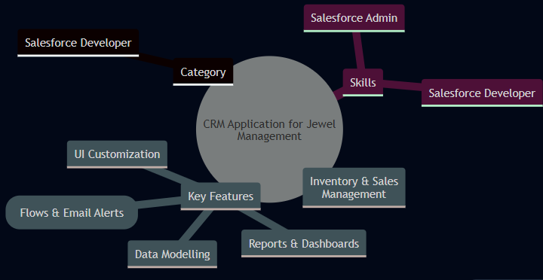

**Jewel Management:**

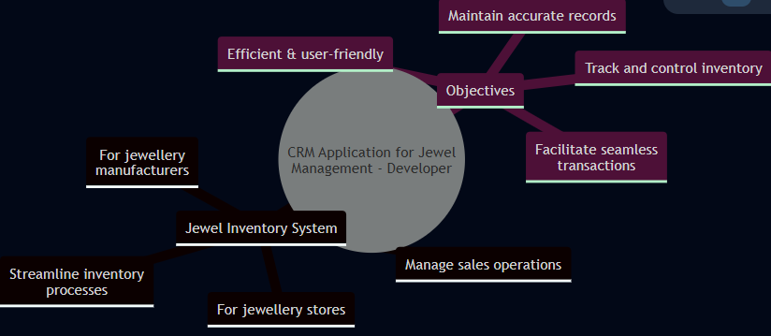

### Purpose

## The primary goal of this project is to provide jewellery enterprises with a system that simplifies the management of inventory, clientele, and sales operations. It minimizes manual effort, enhances precision in maintaining records, and supports improved monitoring, regulatory compliance, and communication across the jewellery management workflow.

**DEVELOPMENT PHASE**

Creating Developer Account:

By using this URL - <https://www.salesforce.com/form/developer-signup/?d=pb>

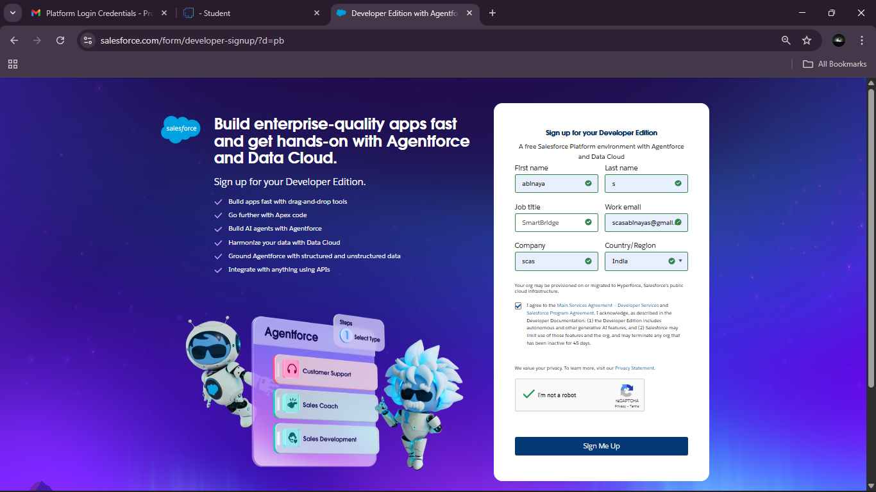

**Account Activation:**

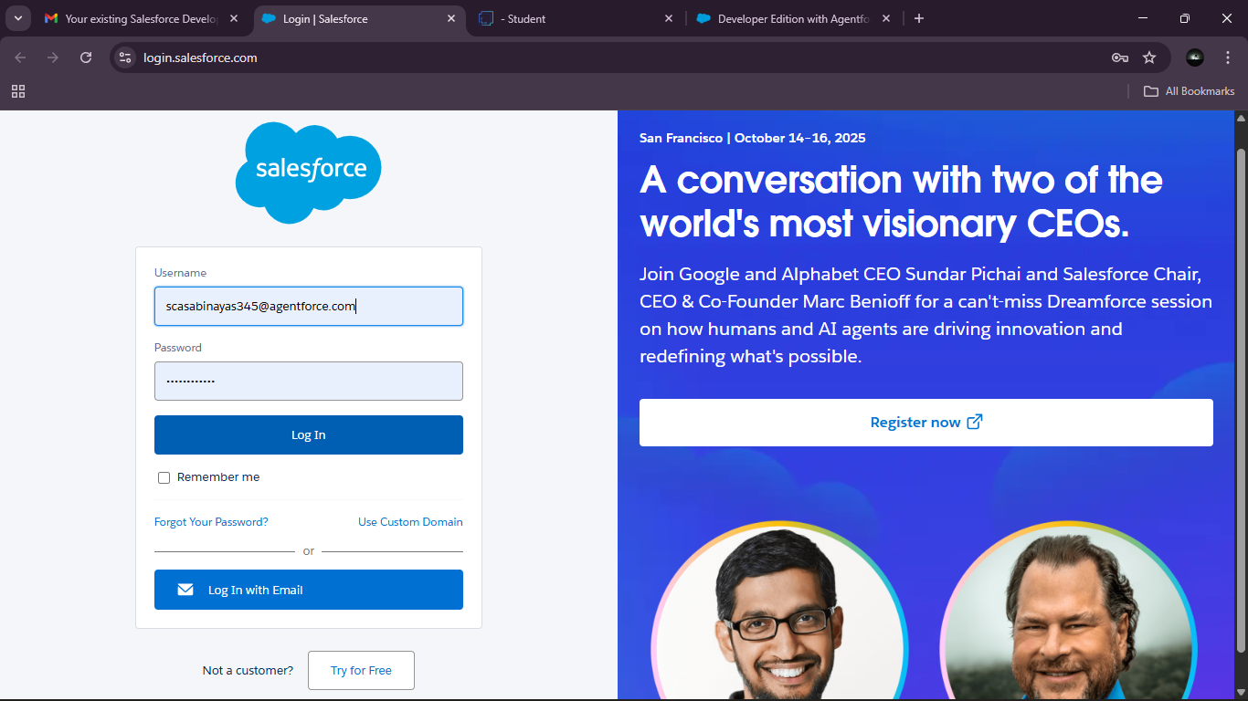

### Create Jewel Customer Object: The purpose of creating a Jewel Customer custom object is to store and manage information about Customer.

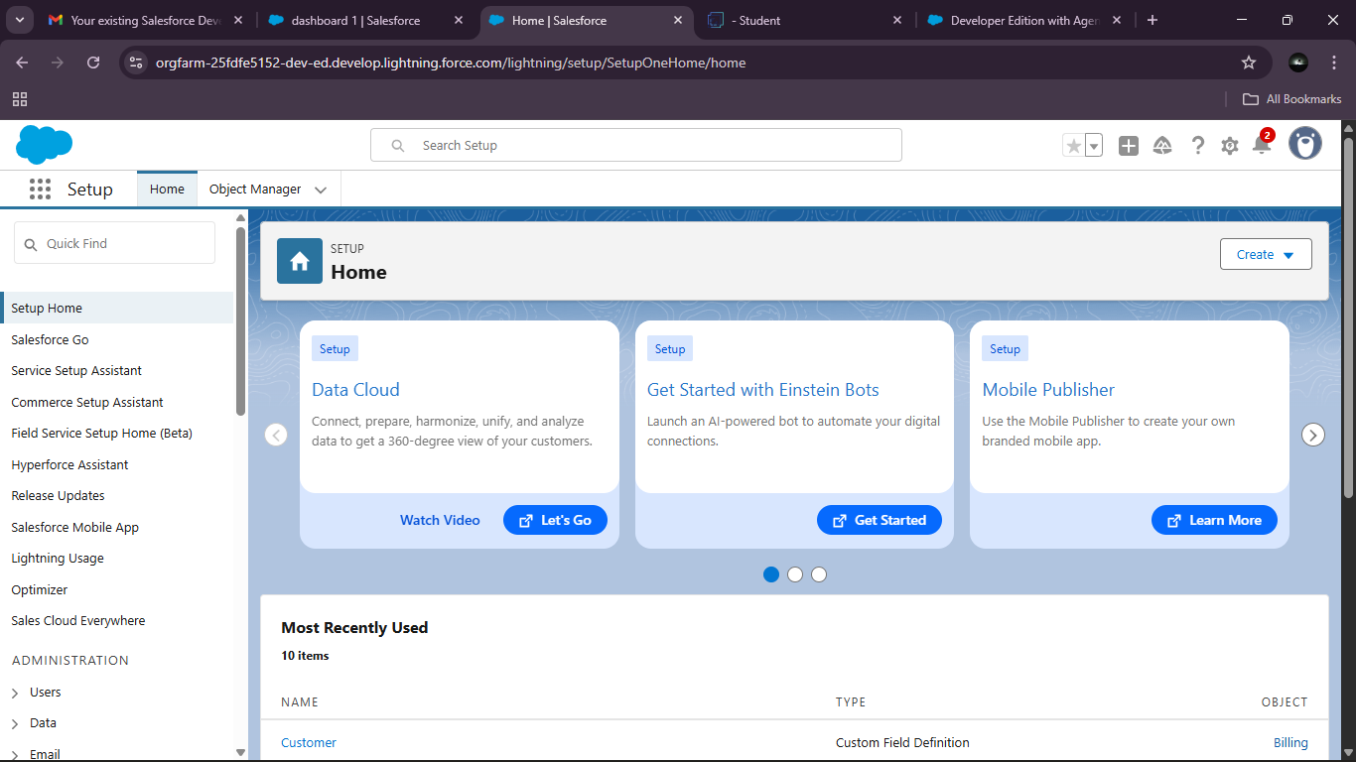

From the setup page:

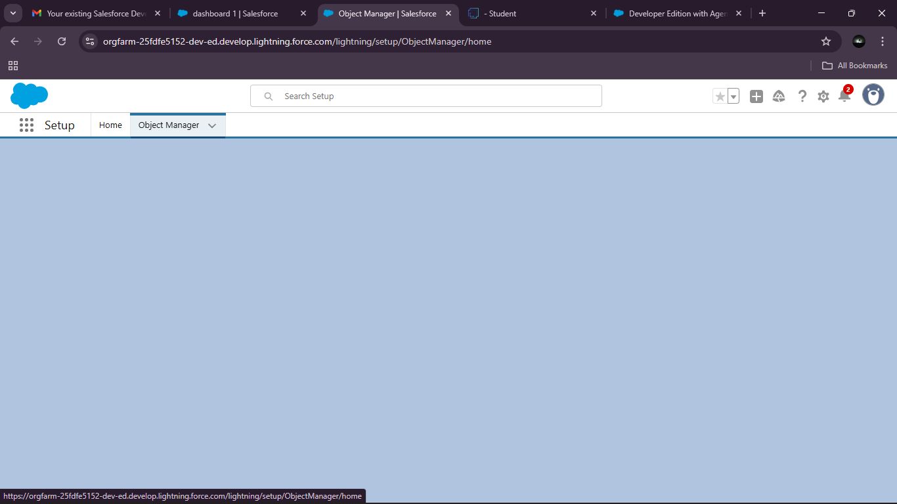

Object Manager -Custom Object:

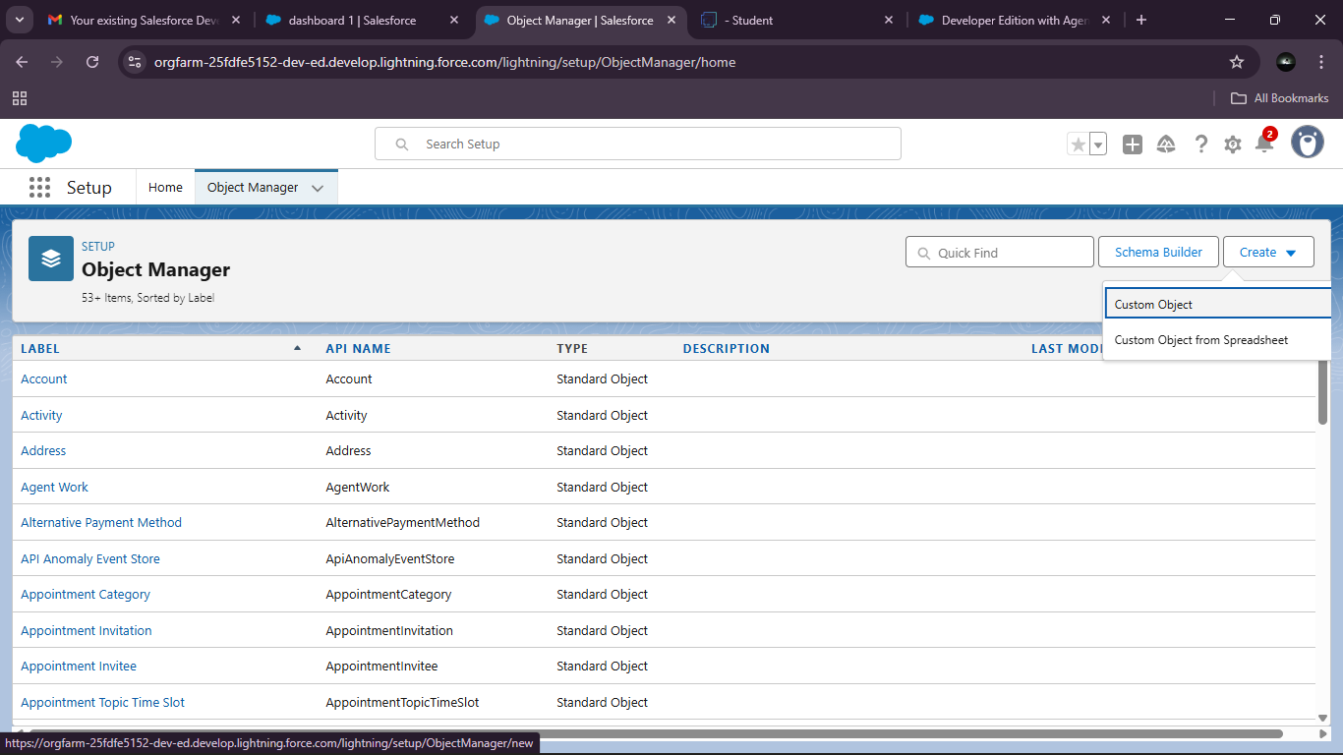

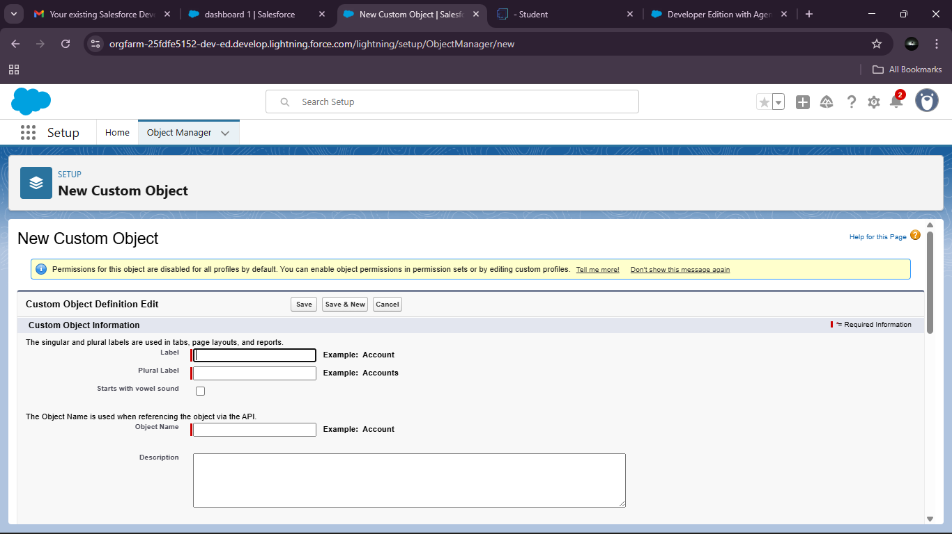

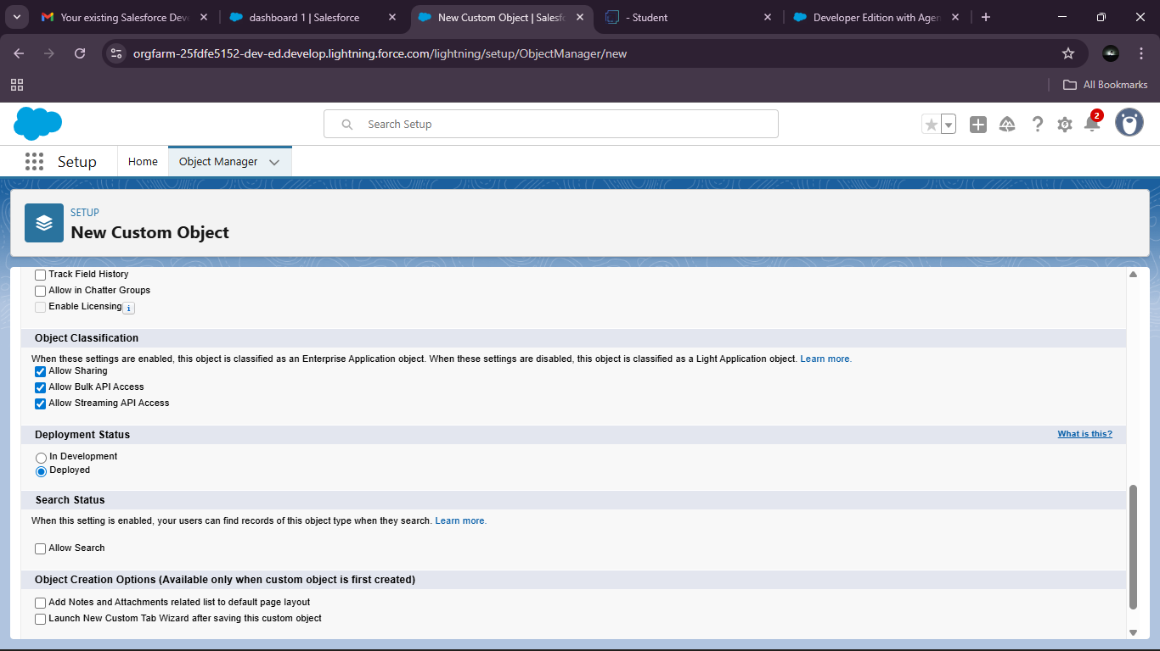

Tabs:

A tab is like a user interface that is used to build records for objects and to view the records in the objects.

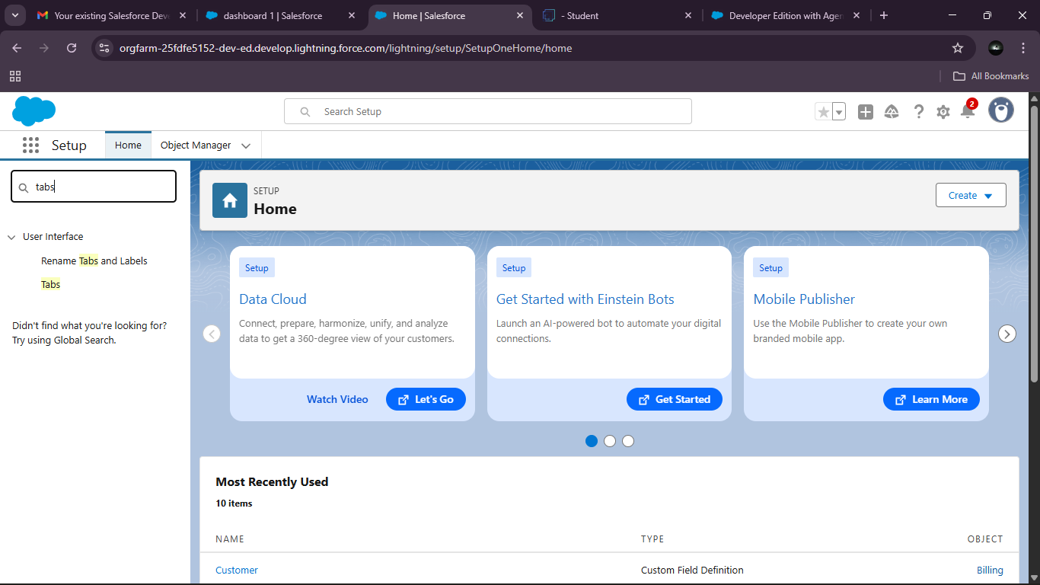

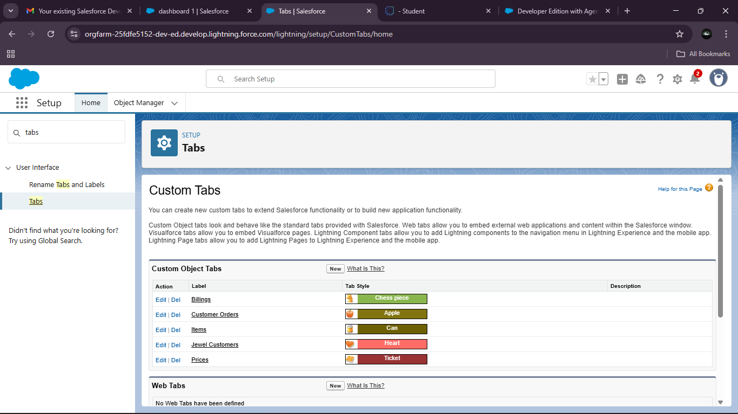

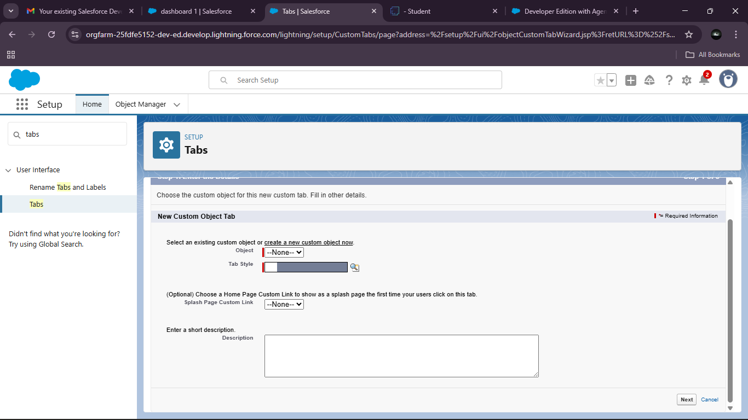

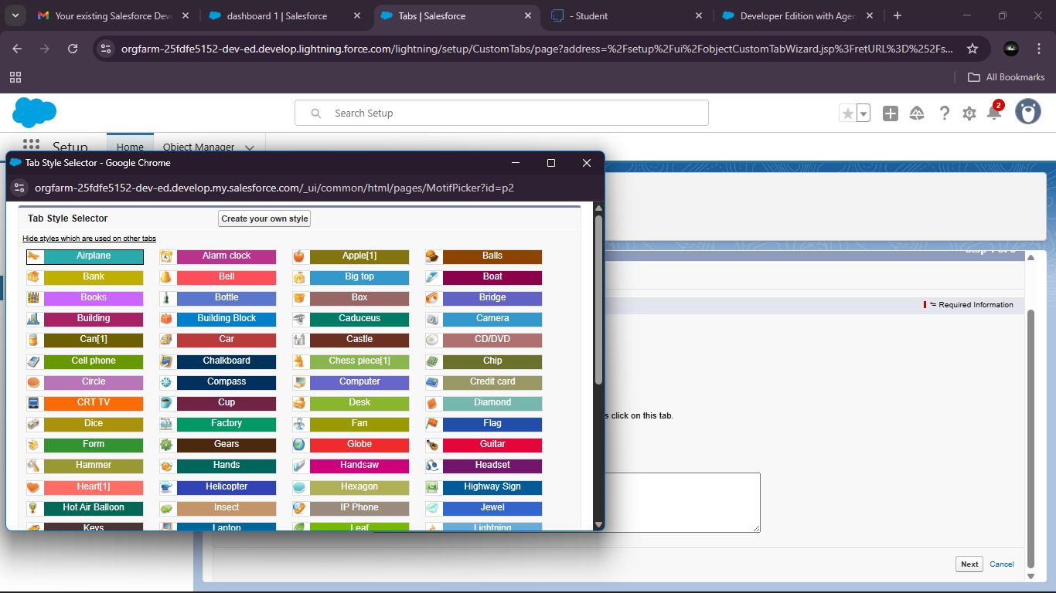

### The Lightning App:

An app is a collection of items that work together to serve a particular function. In Lightning Experience, Lightning apps gives users access to sets of objects, tabs, and other items all in one convenient bundle in the navigation bar.

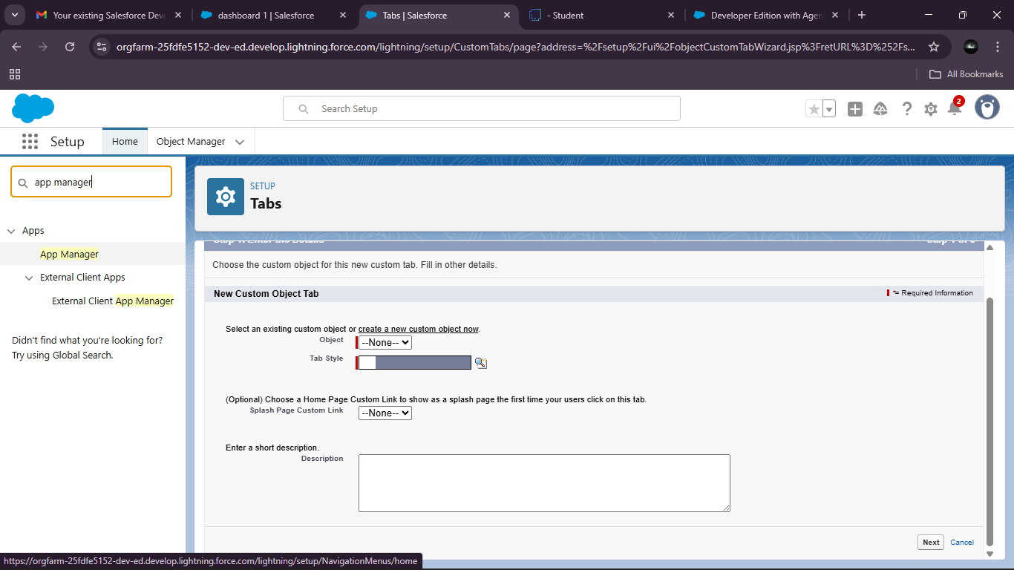

Create a Lightning App: Jewellery Inventory System.

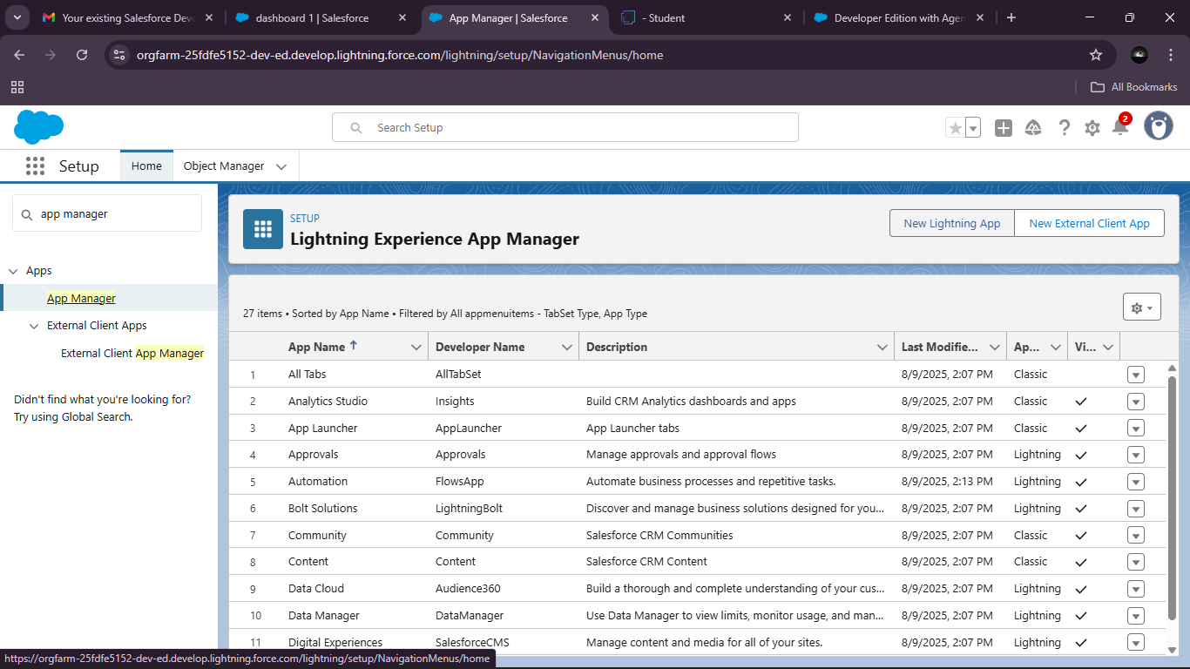

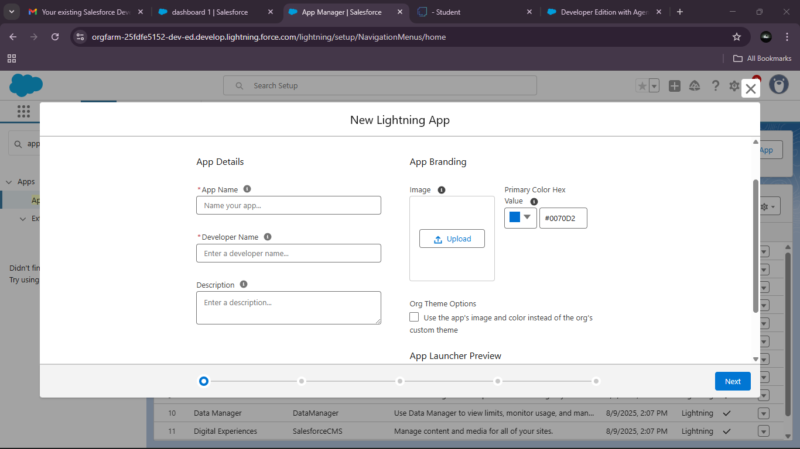

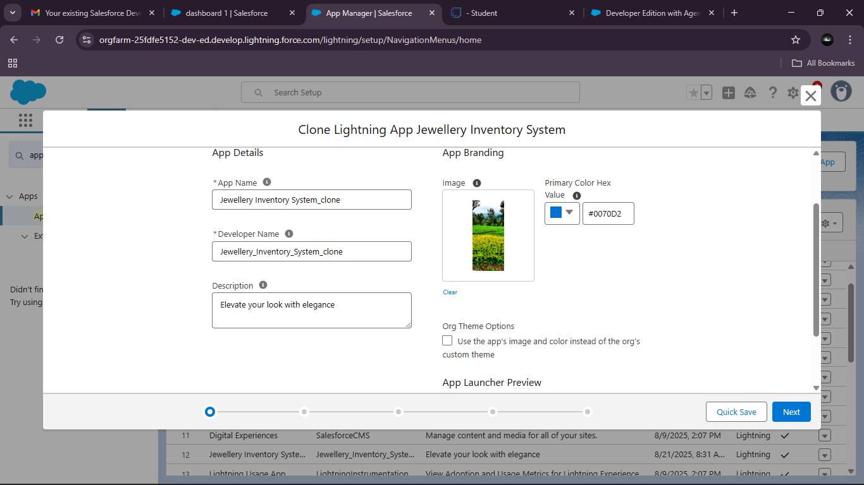

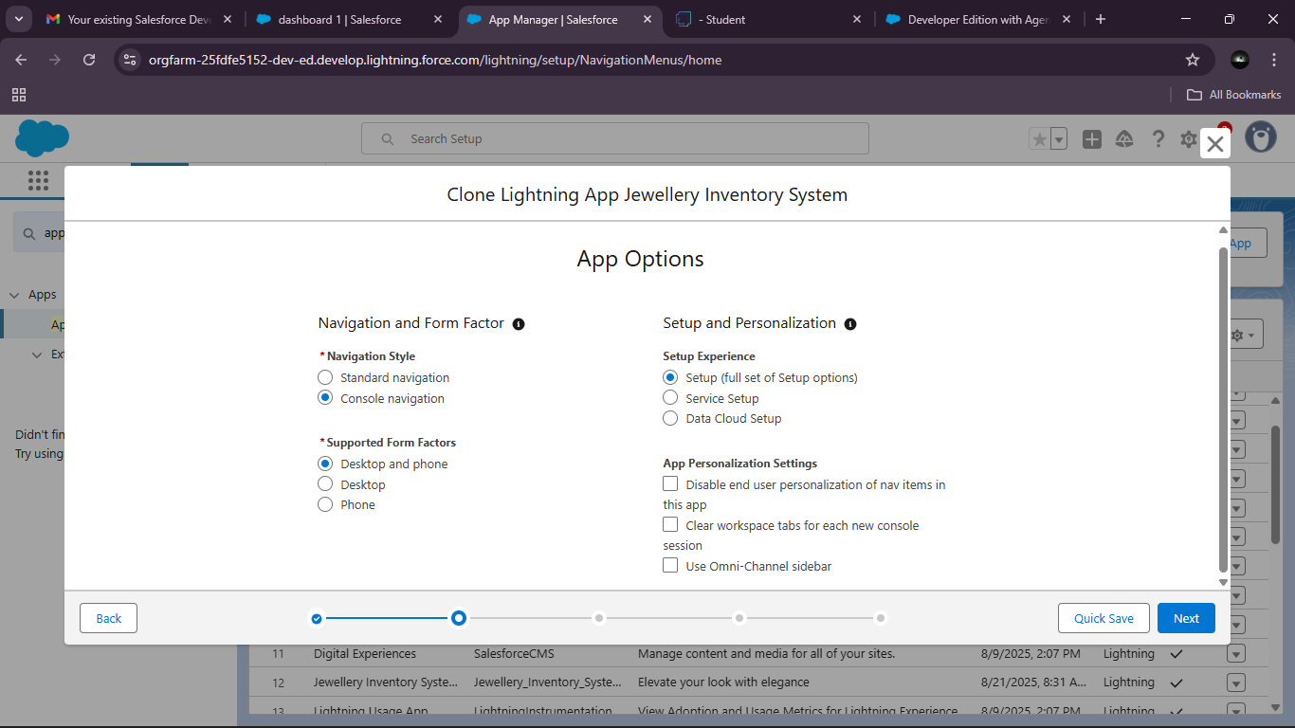

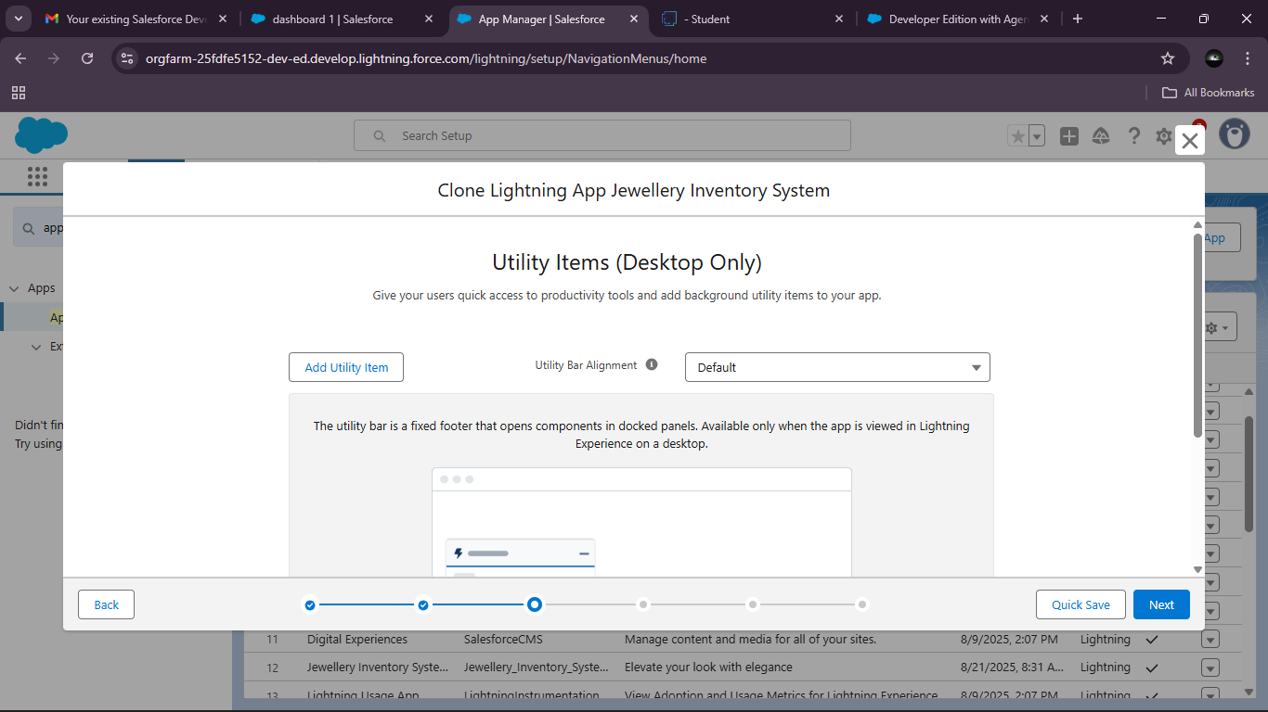

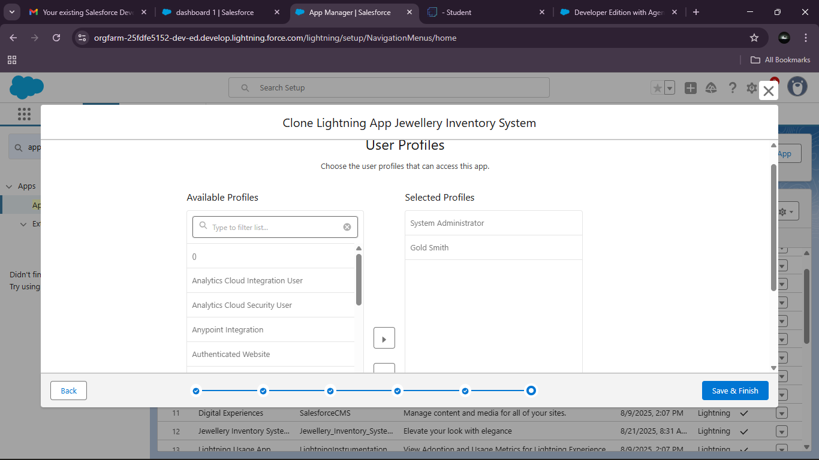

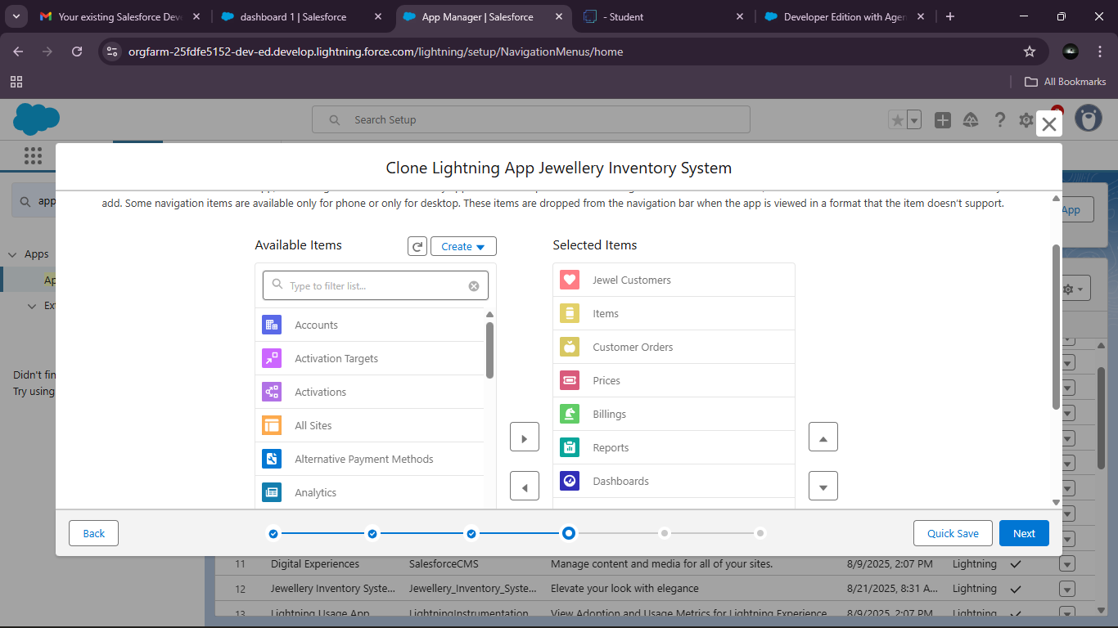

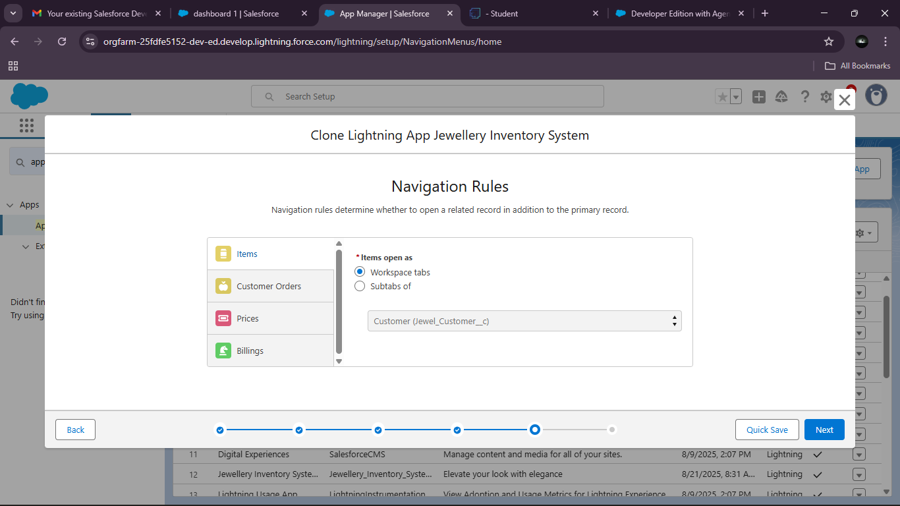

**Fields:**

### Creating Lookup Relationship:

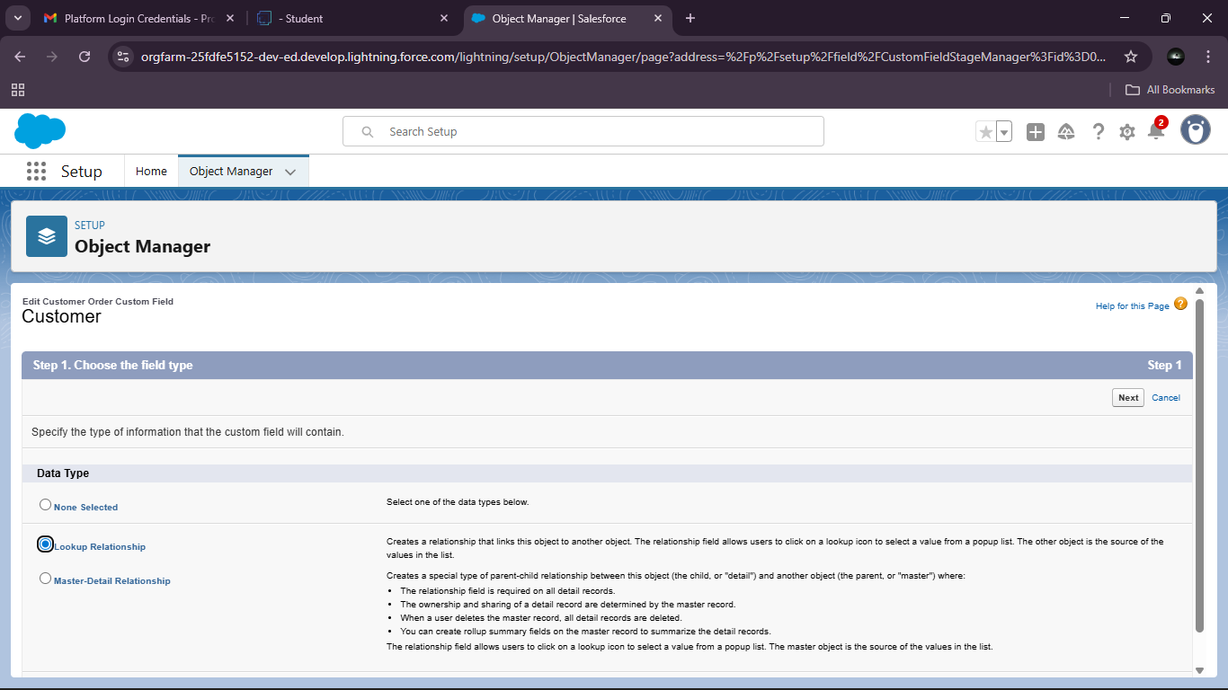

### Creating a Master-Detail Relationship:

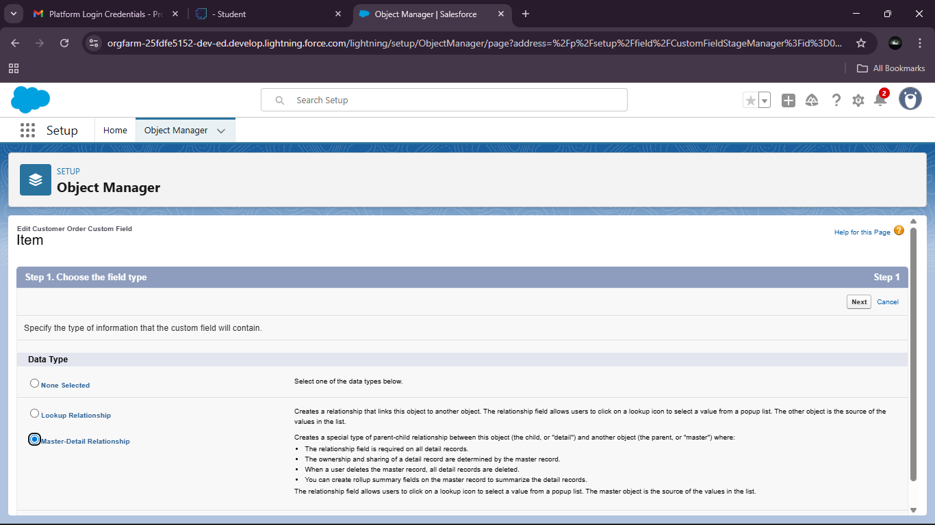

### Creating Text Field in Jewel Customer Object:

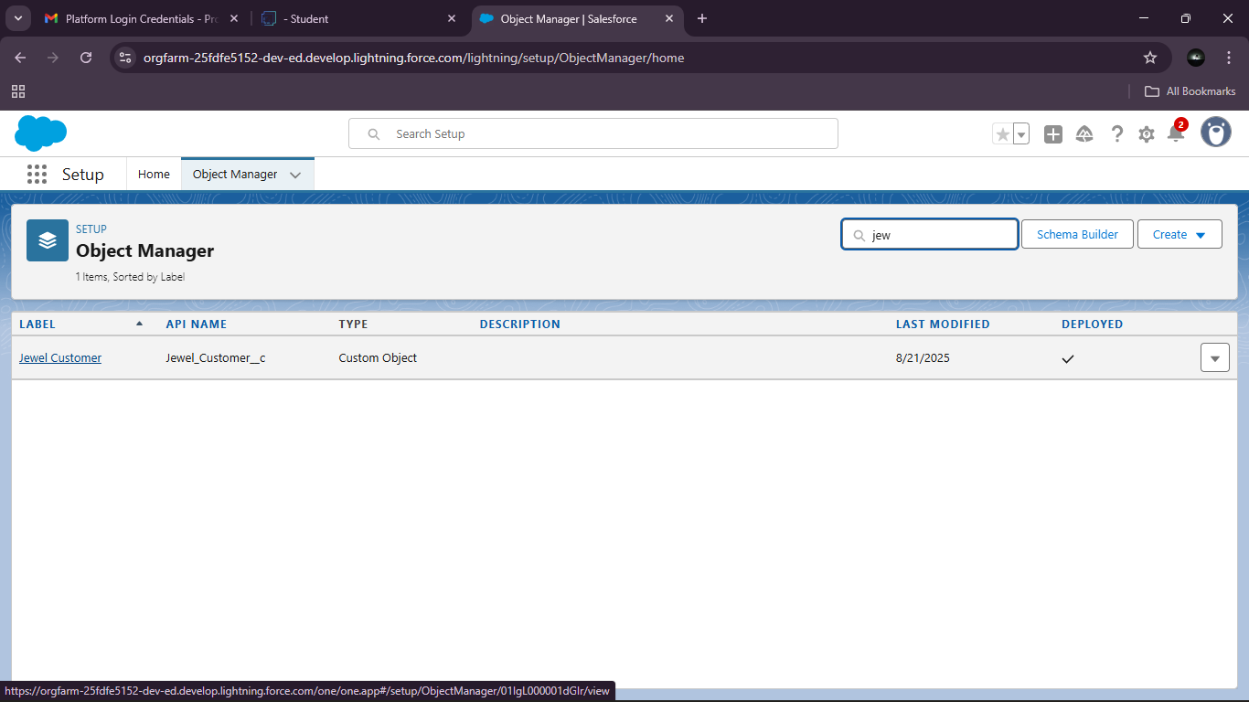

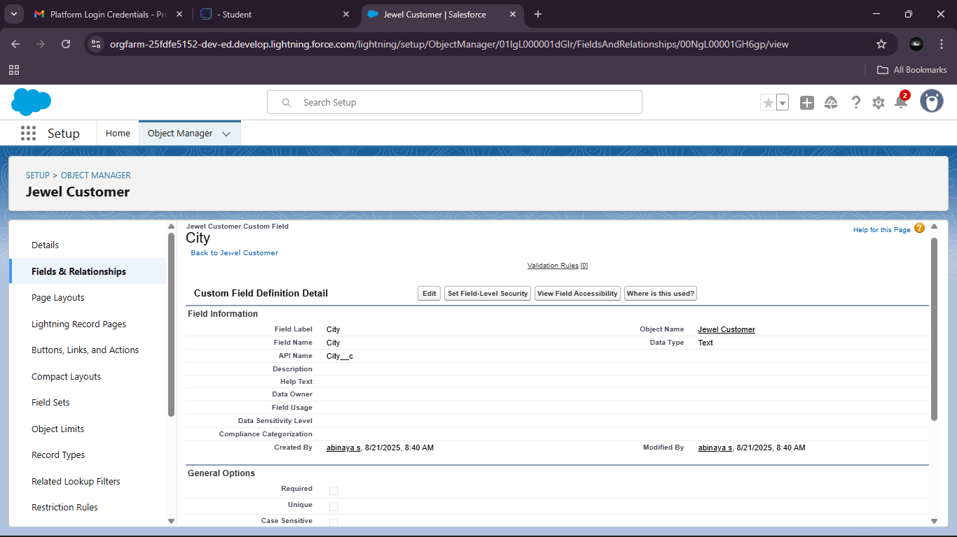

### Creating the Phone field in object Jewel Customer:

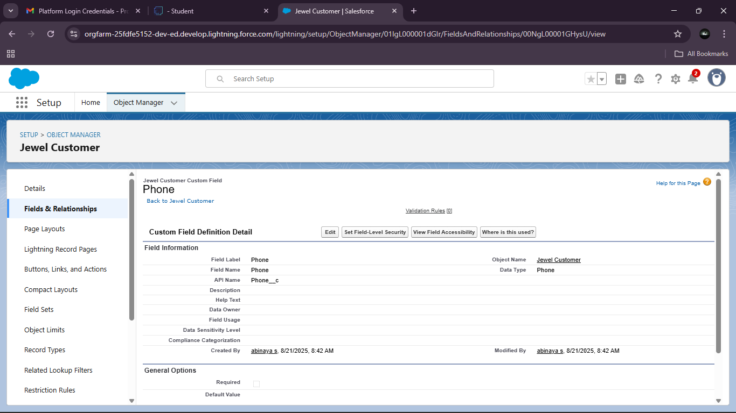

### Creating the Email field in object Jewel Customer:

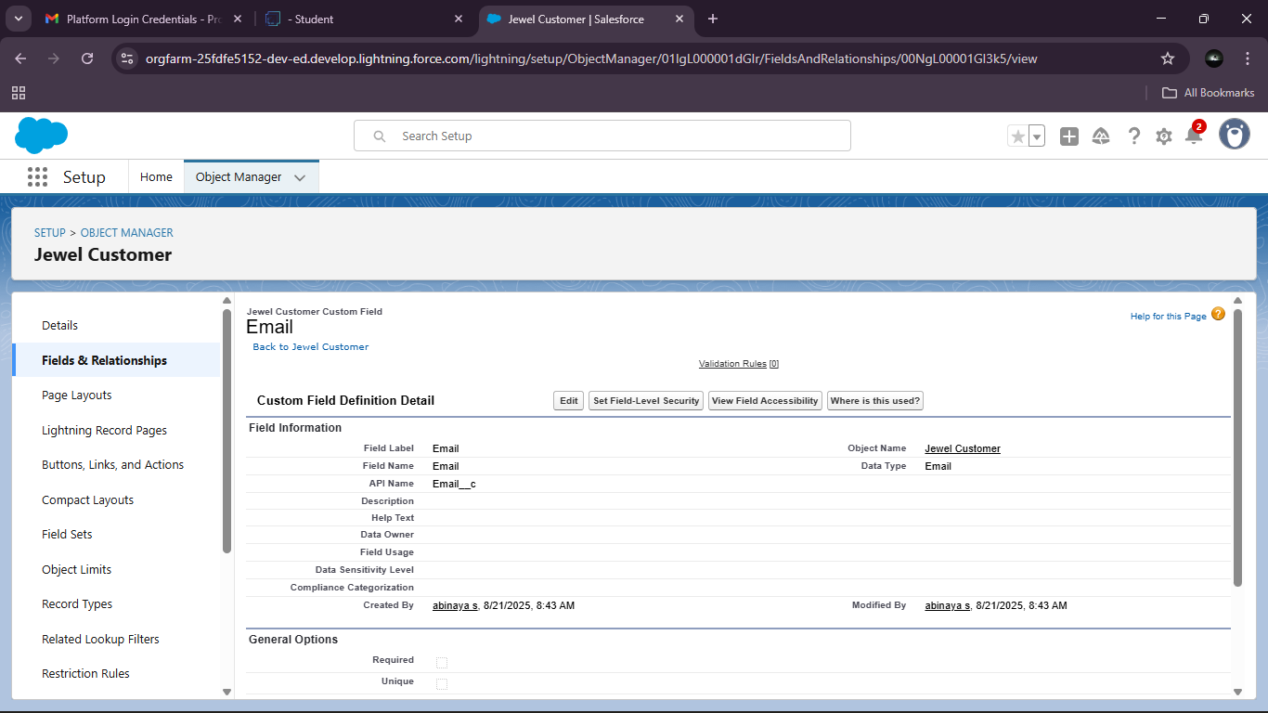

### Creating the number field in Item object:

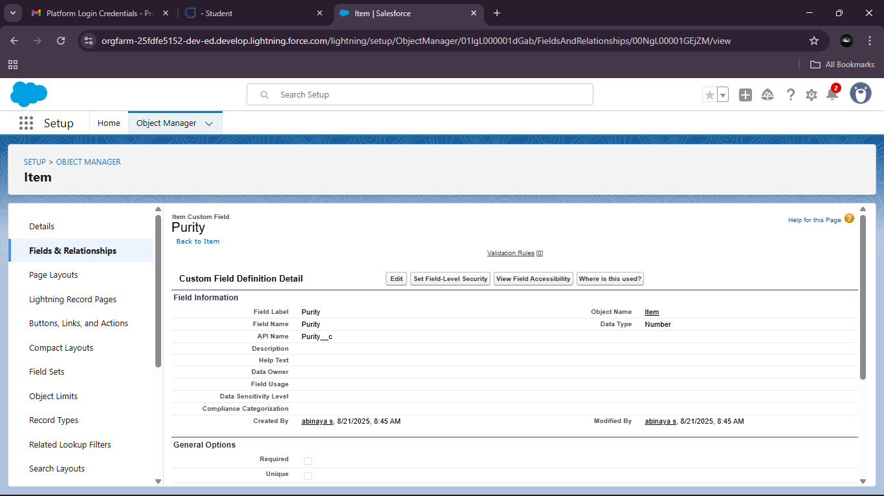

### Creating Picklist Field in Item Object:

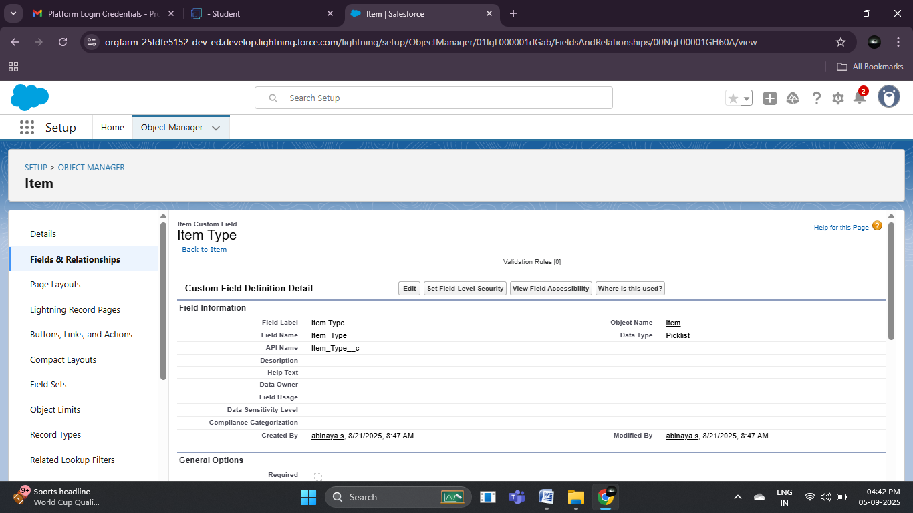

### Creating Currency Field in Price Object:

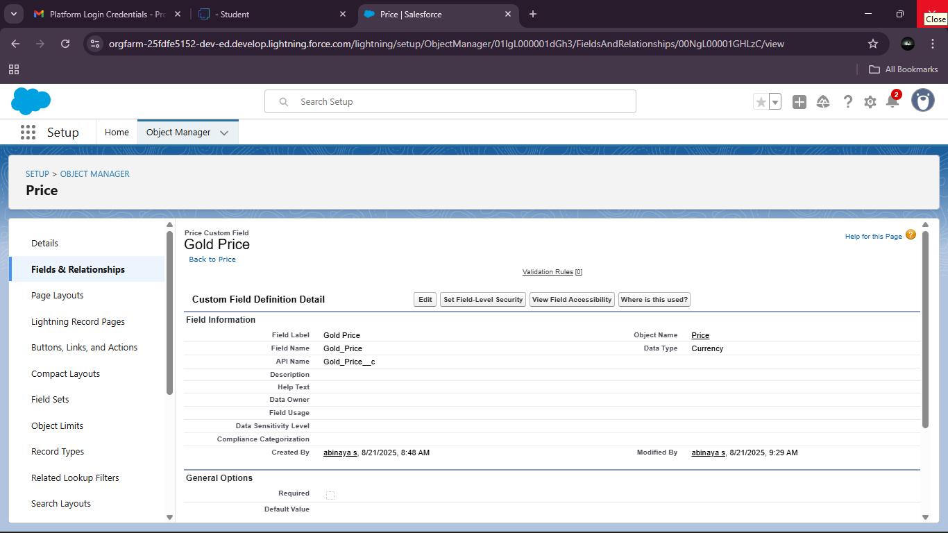

Creating Formula Field(Cross Object) in Item Object:

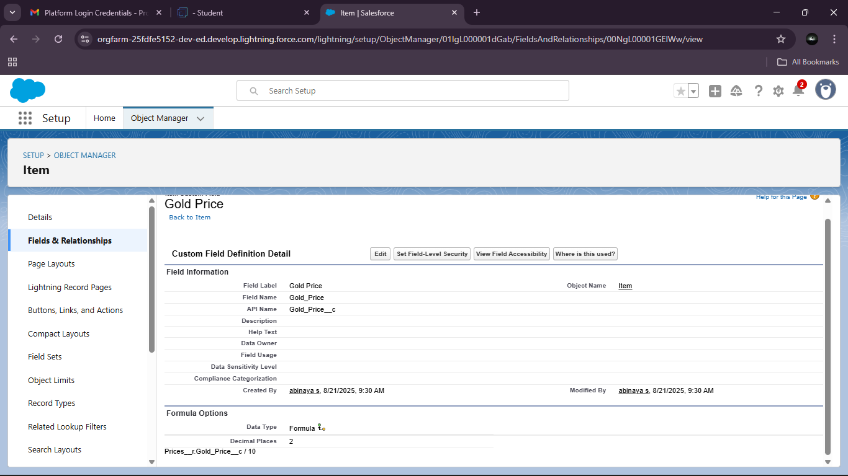

### Creating Remaining Fields in Objects:

PRICE:

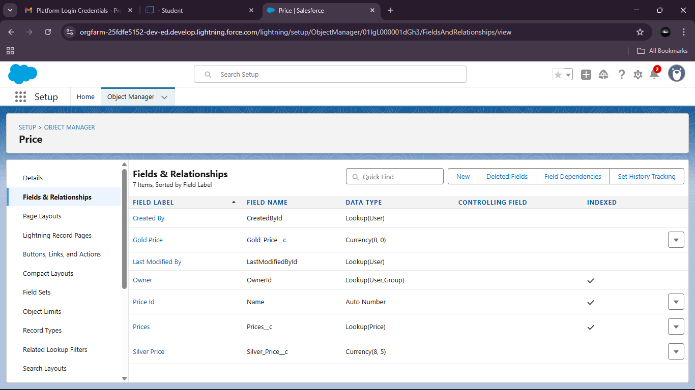

Jewel Customer:

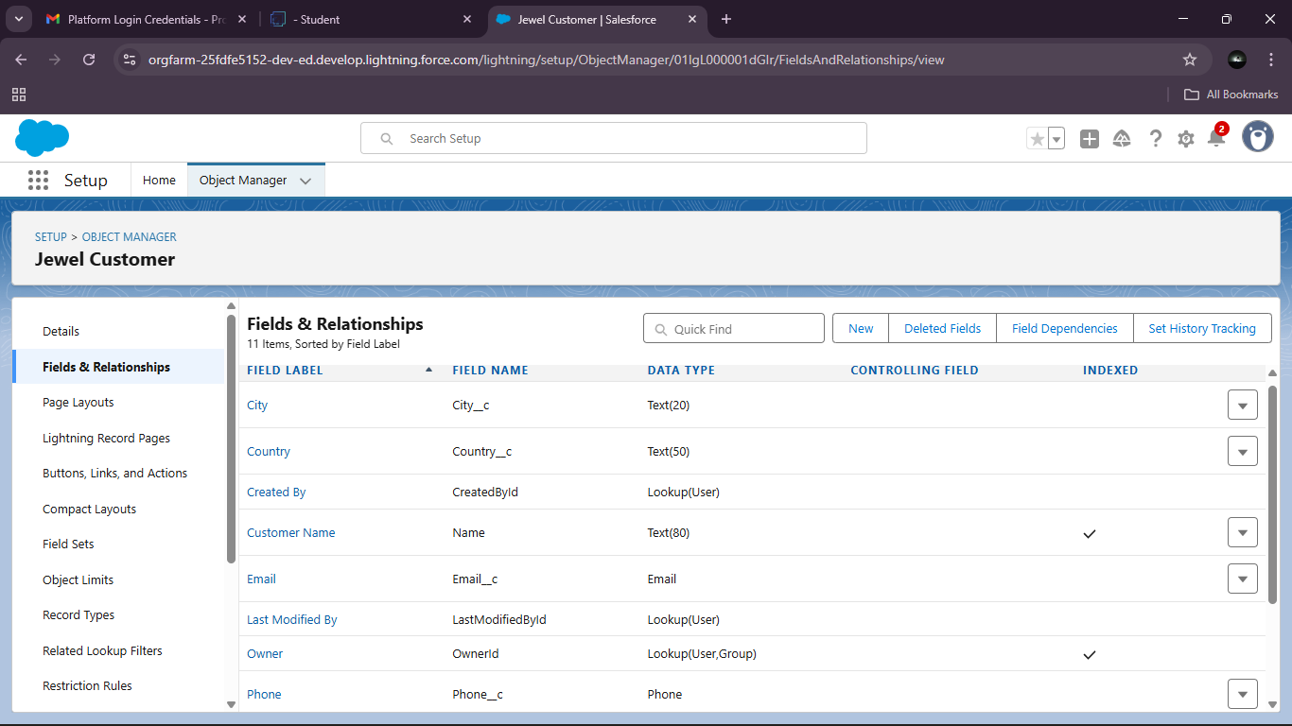

Item:

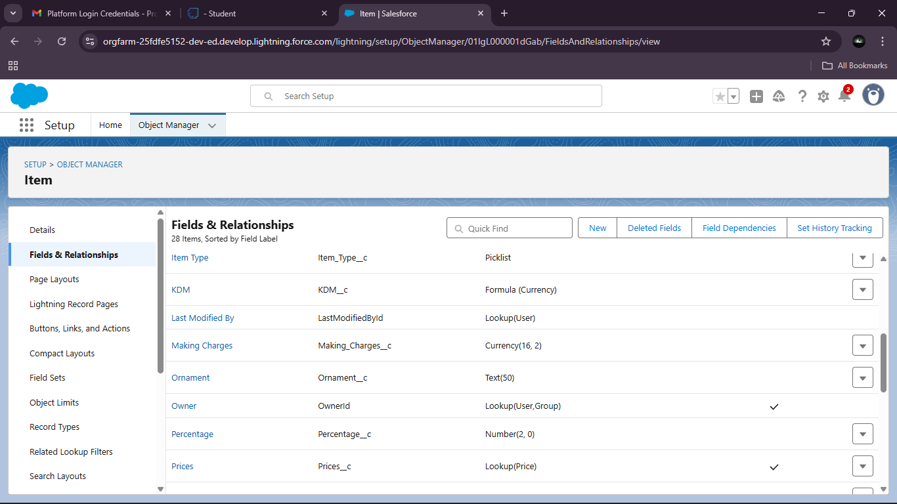

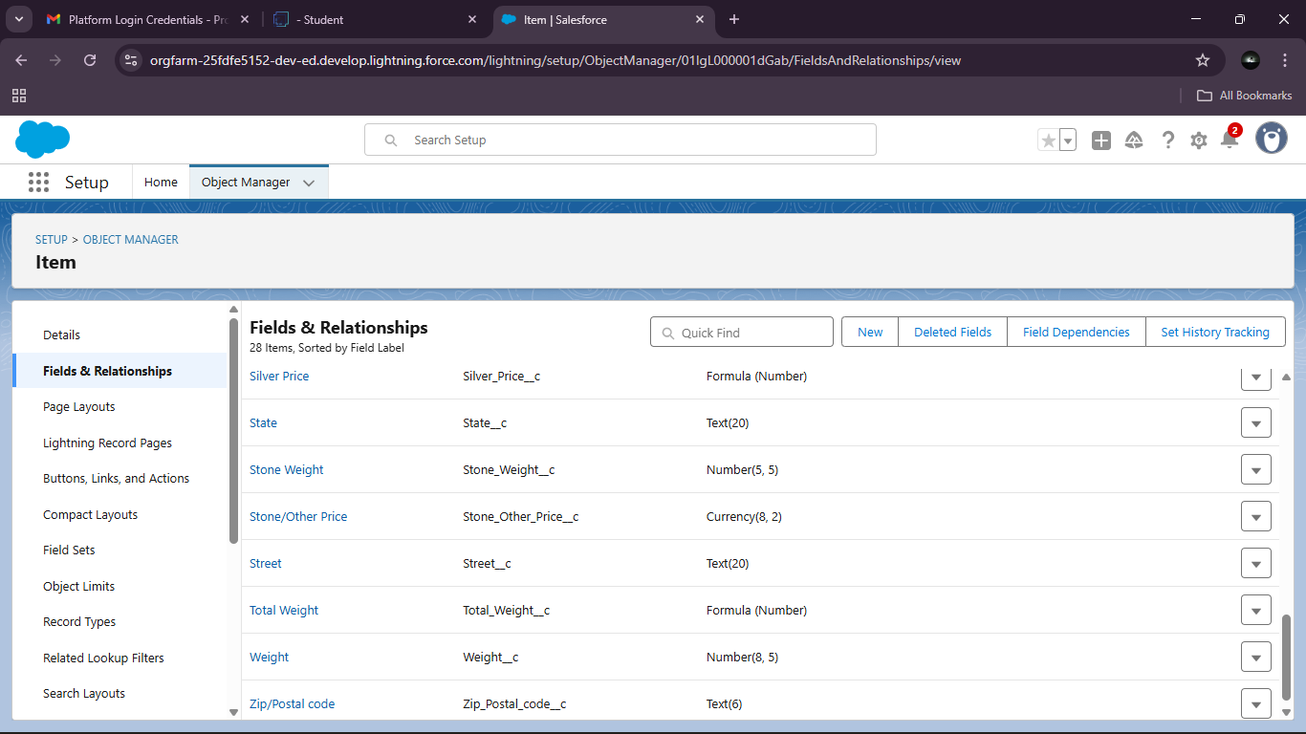

CUSTOMER ORDER:

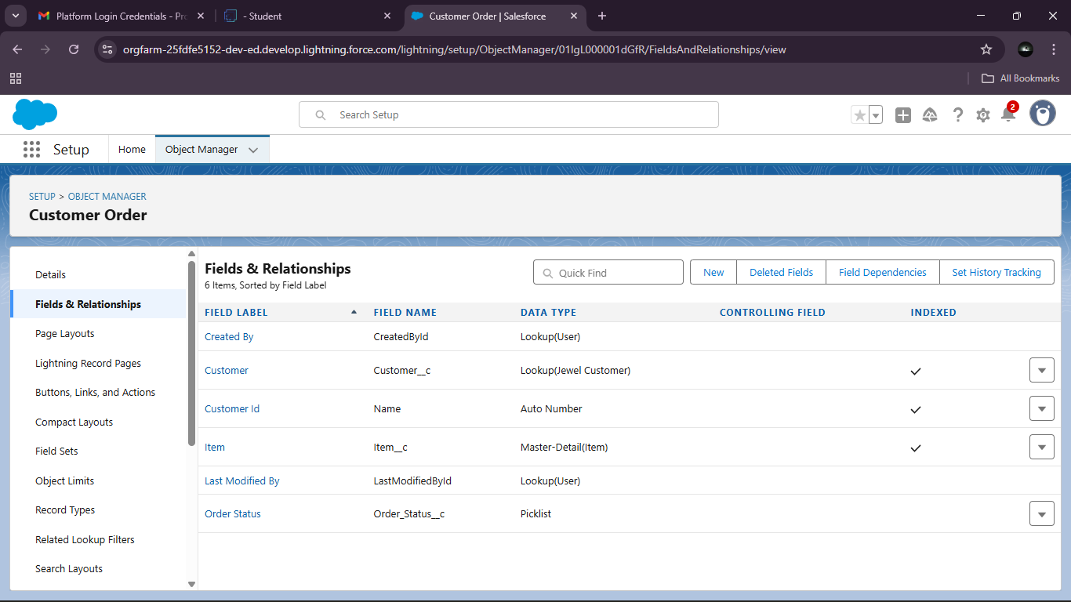

BILLING:

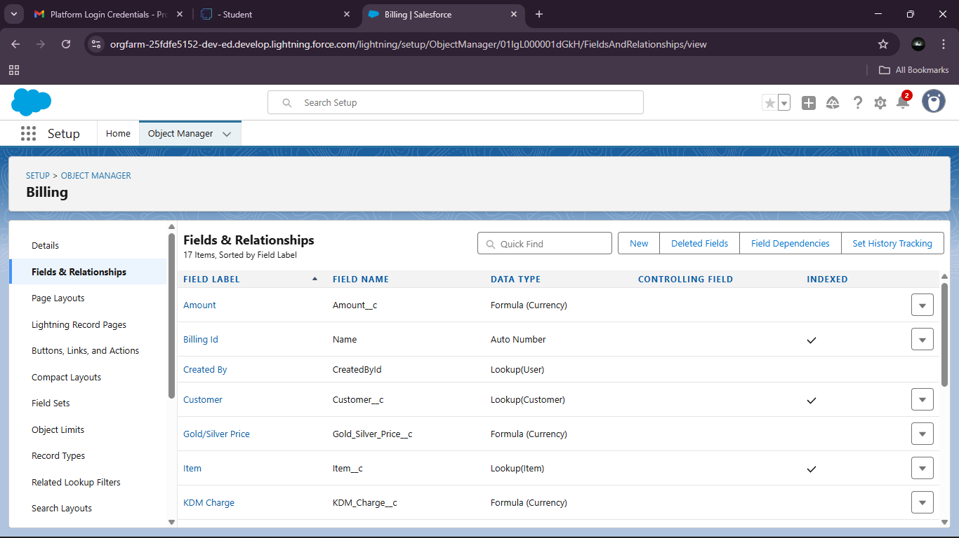

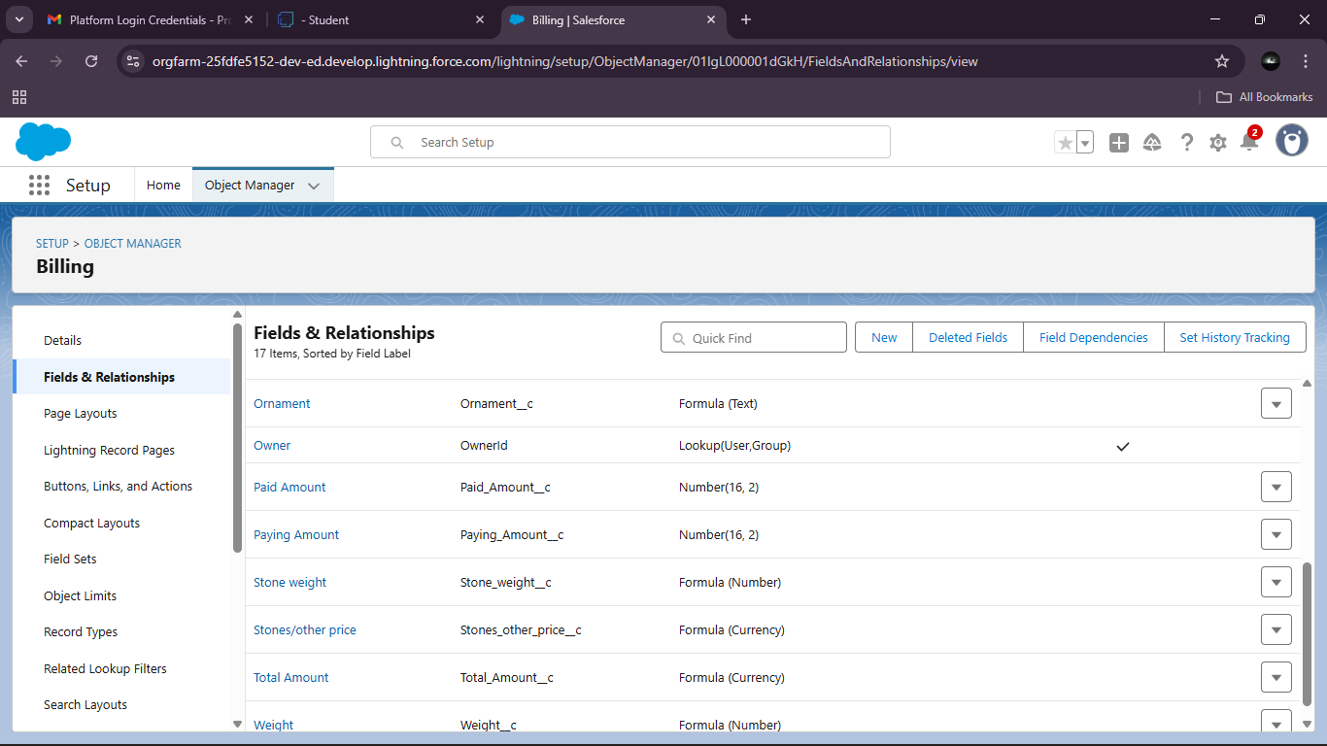

### Schema Builder:

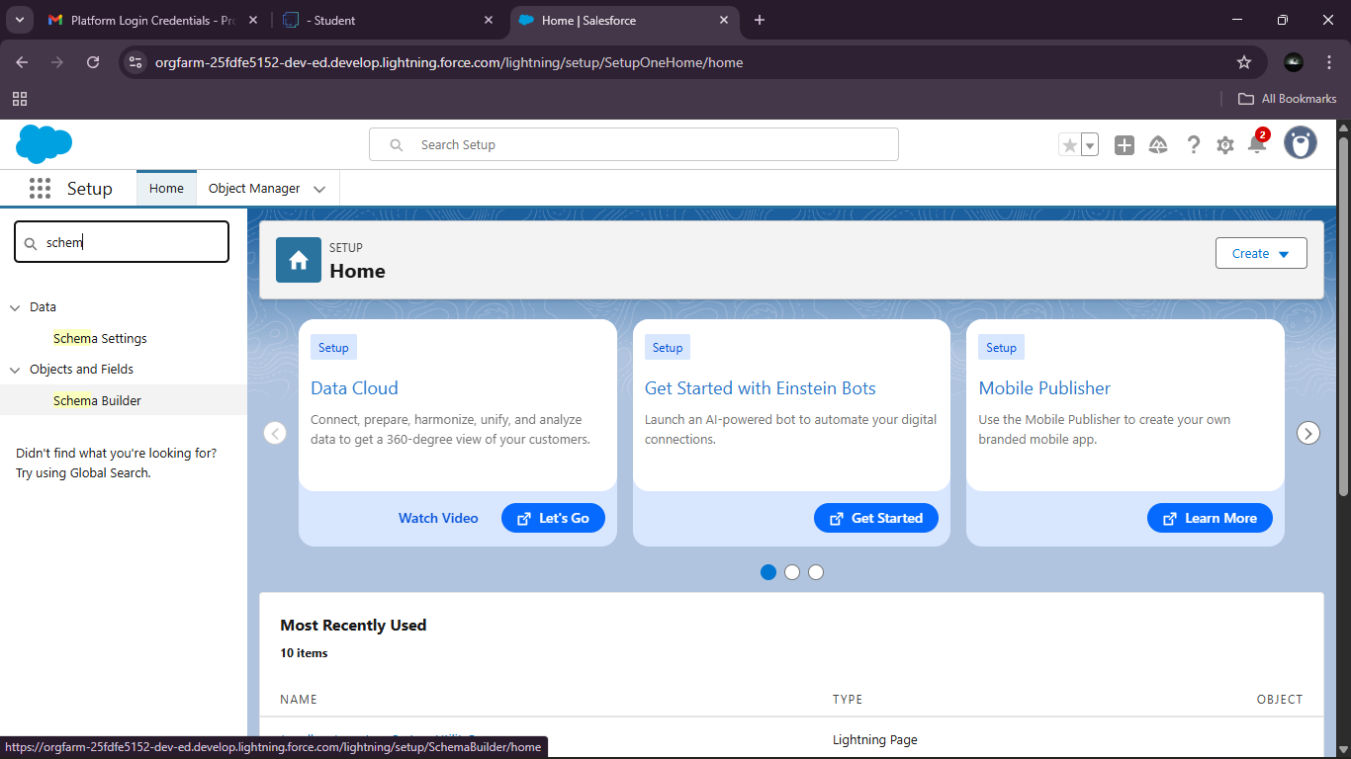

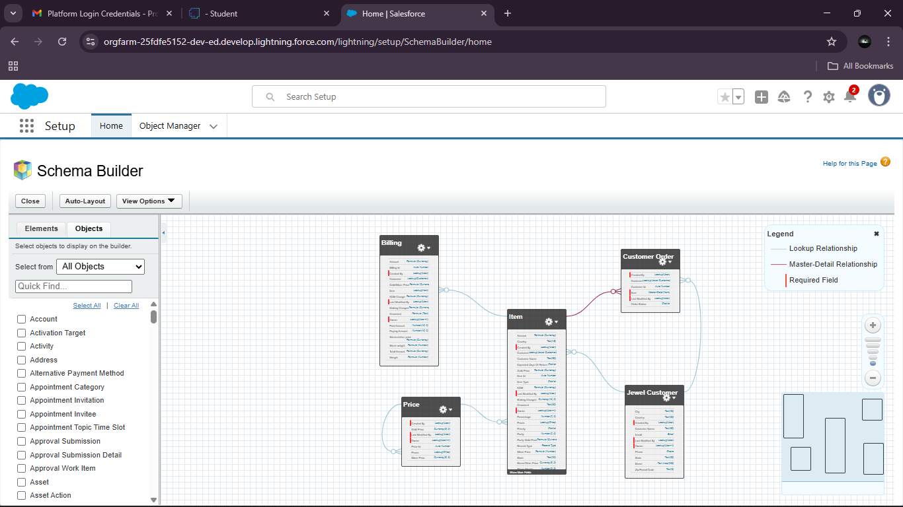

Creating the Field Dependencies:

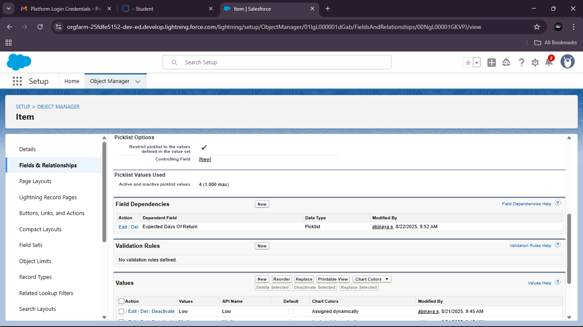

### Creating the validation rule:

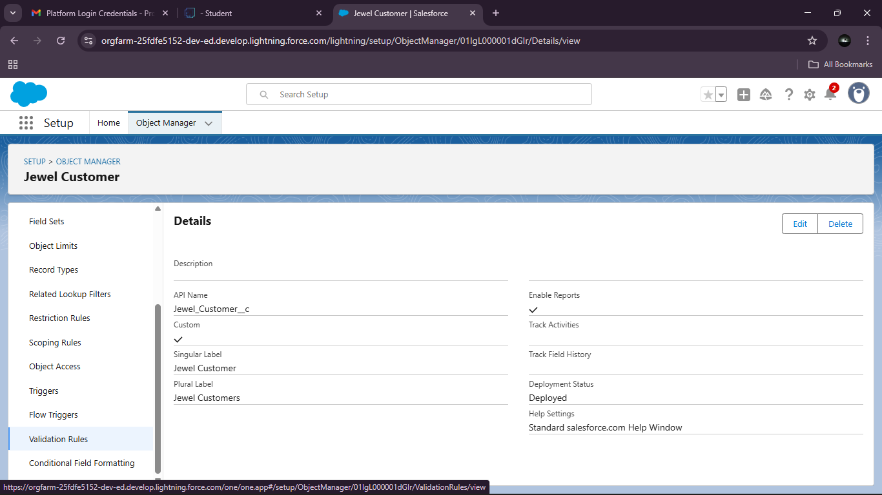

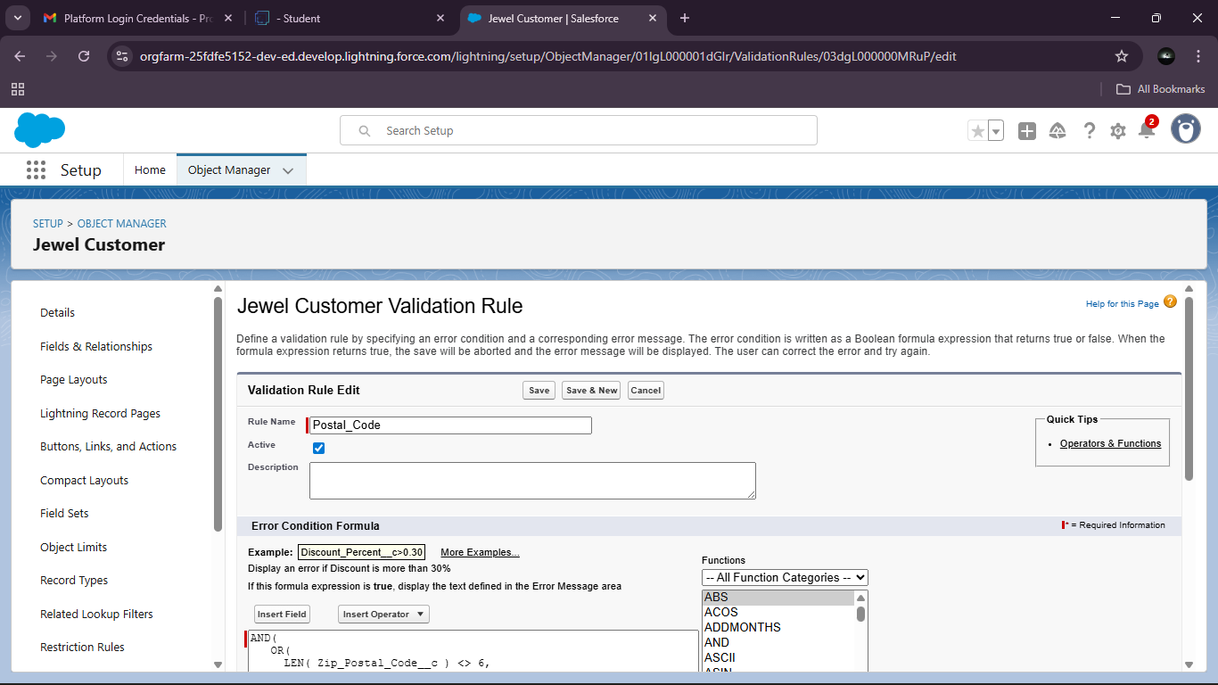

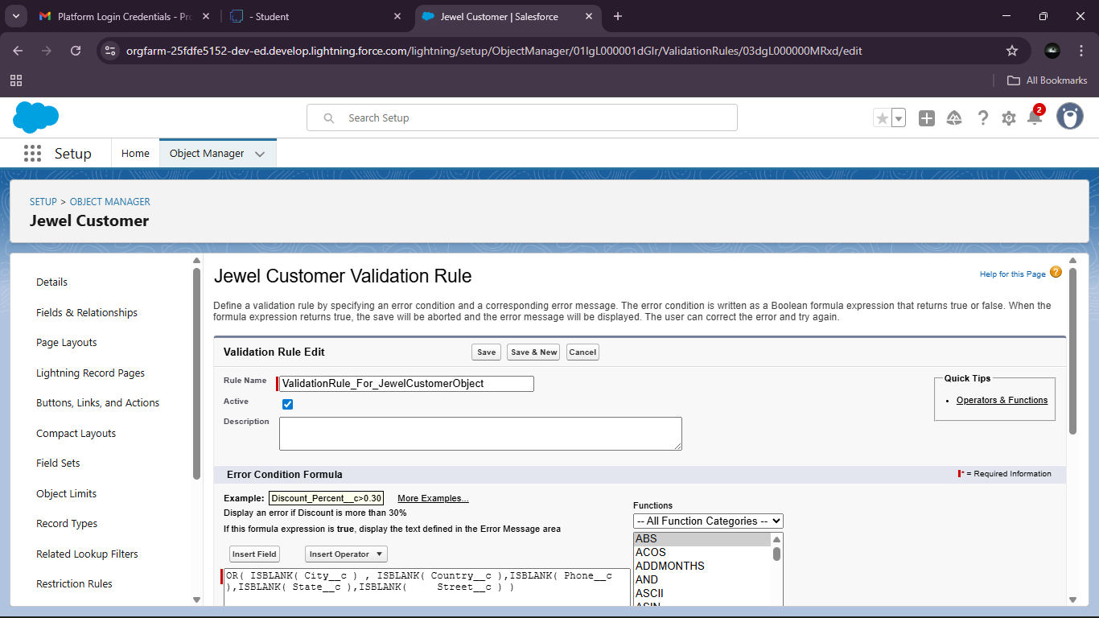

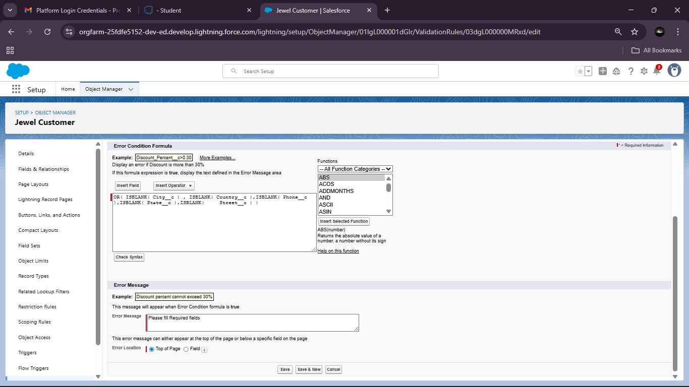

Profiles:

A profile is a group/collection of settings and permissions that define what a user can do in salesforce. Profile controls “Object permissions, Field permissions, User permissions, Tab settings, App settings, Apex class access, Visualforce page access, Page layouts, Record Types, Login hours & Login IP ranges.

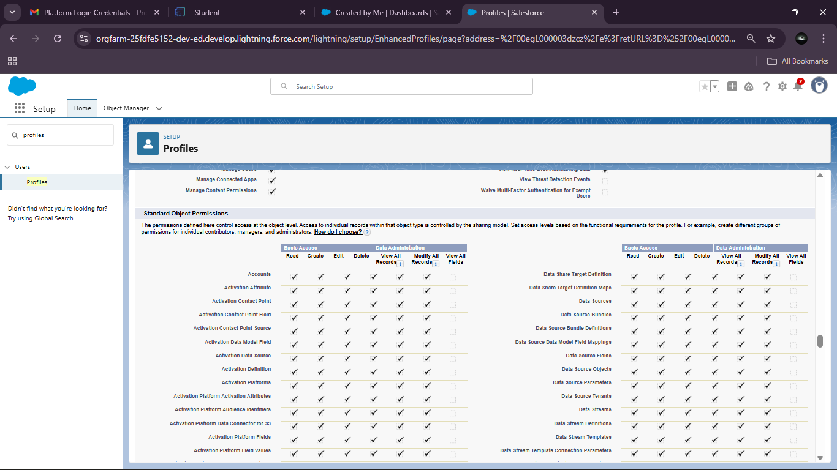

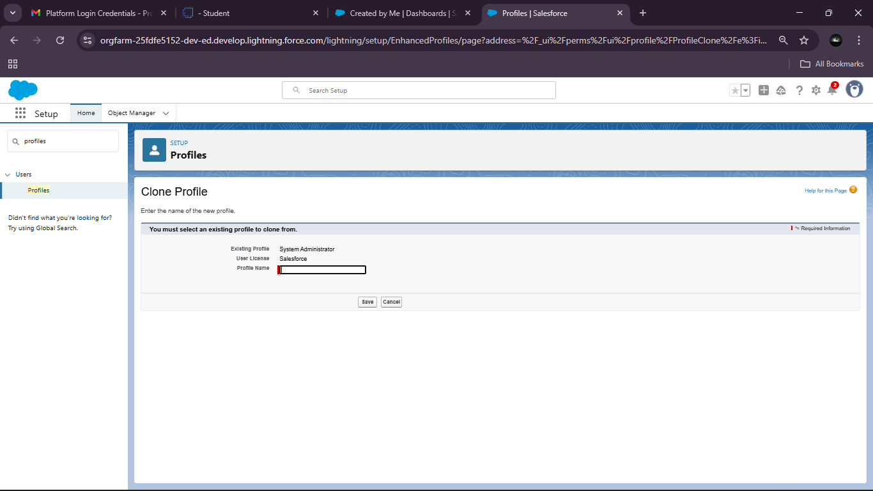

Roles:

A role in Salesforce defines a user's visibility access at the record level. Roles may be used to specify the types of access that people in your Salesforce organisation can have to data. Simply put, it describes what a user could see within the Salesforce organization.

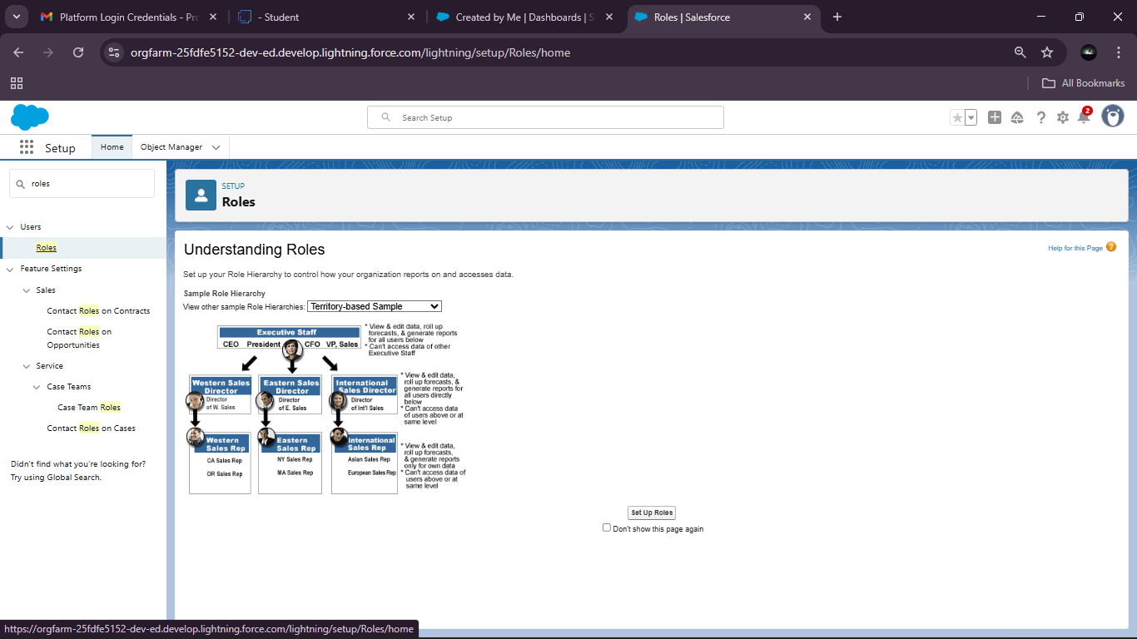

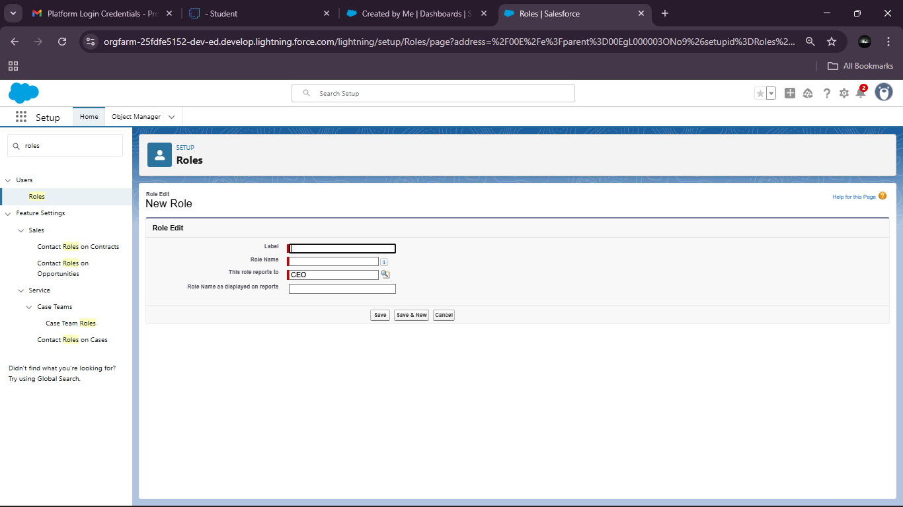

Users:

A user is anyone who logs in to Salesforce. Users are employees at your company, such as sales reps, managers, and IT specialists, who need access to the company's records. Every user in Salesforce has a user account

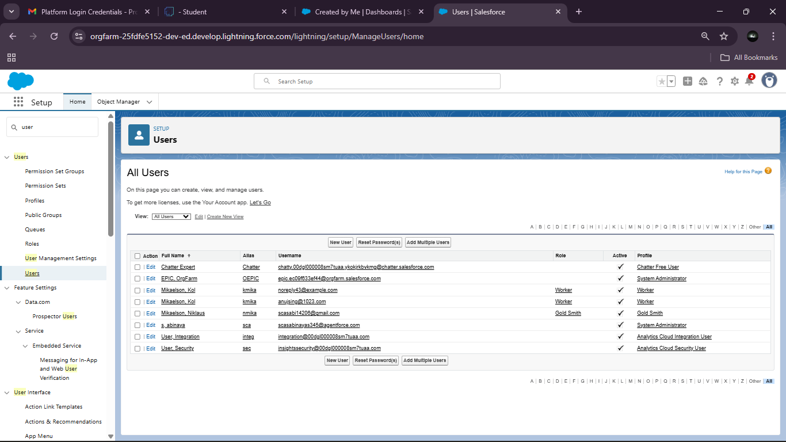

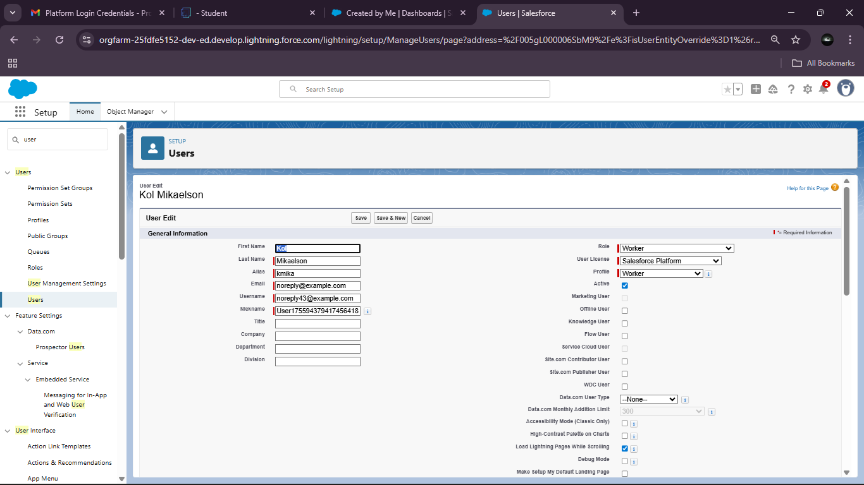

Page layouts:

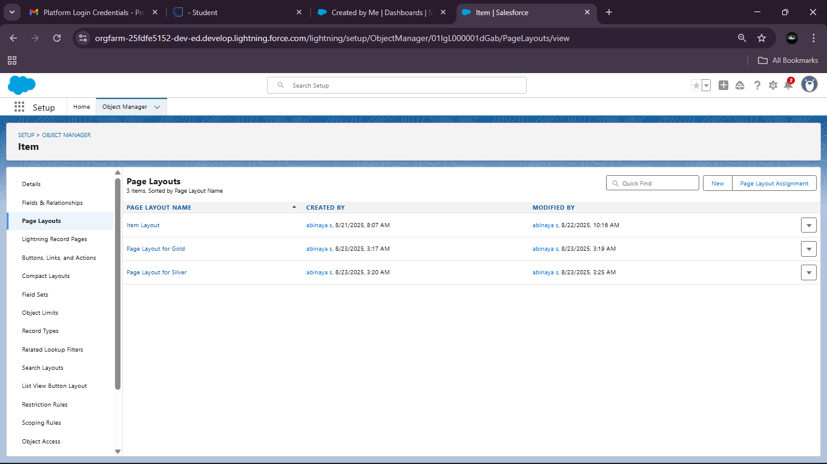

A Gold Page layout:

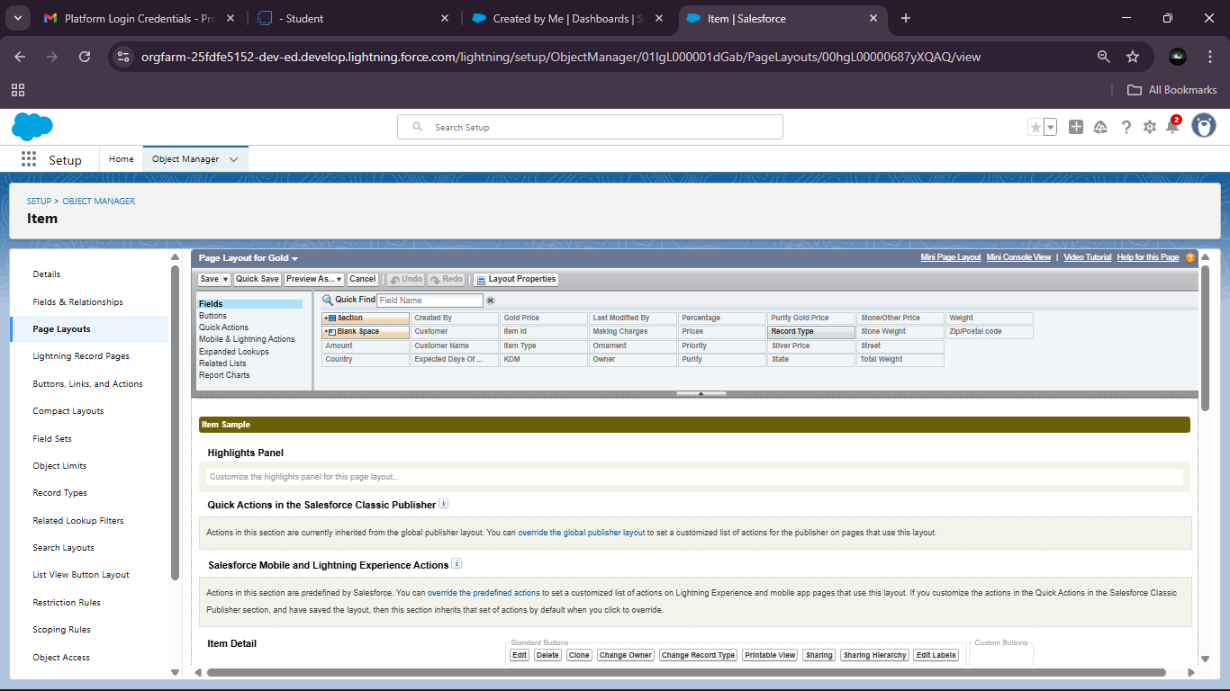

A Silver Page layout:

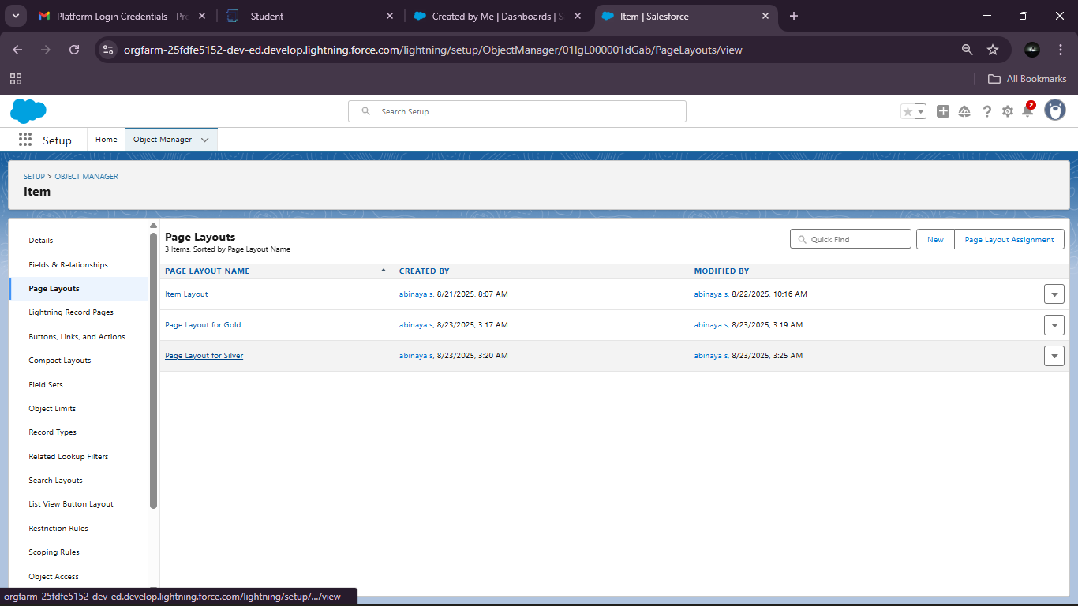

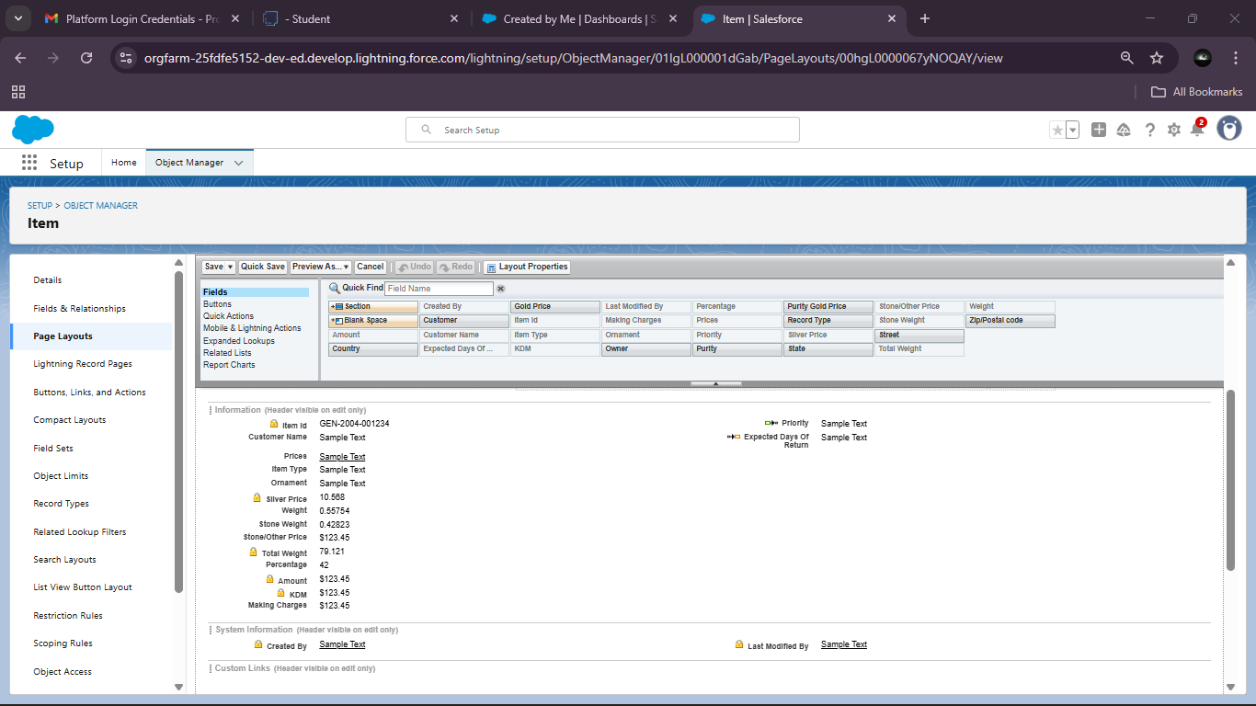

Record Types:

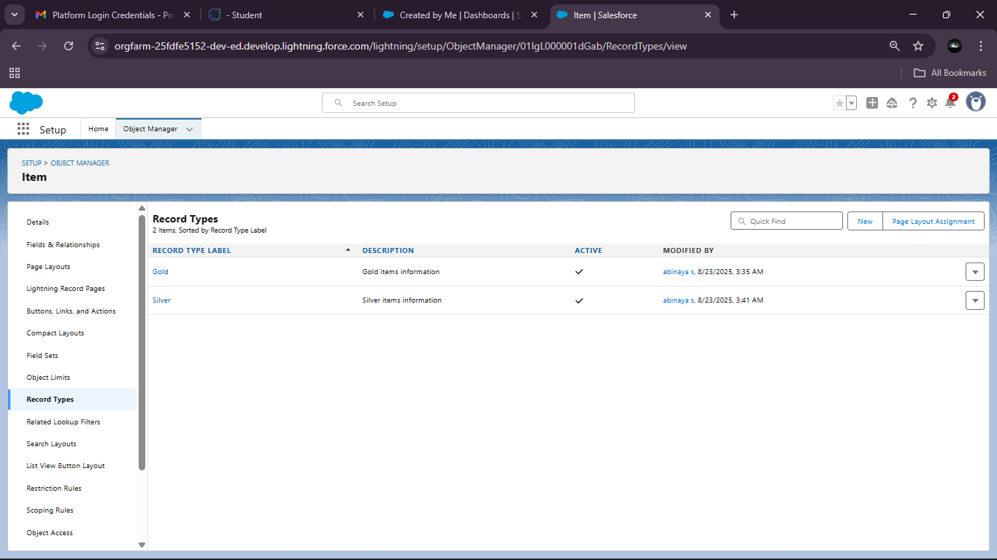

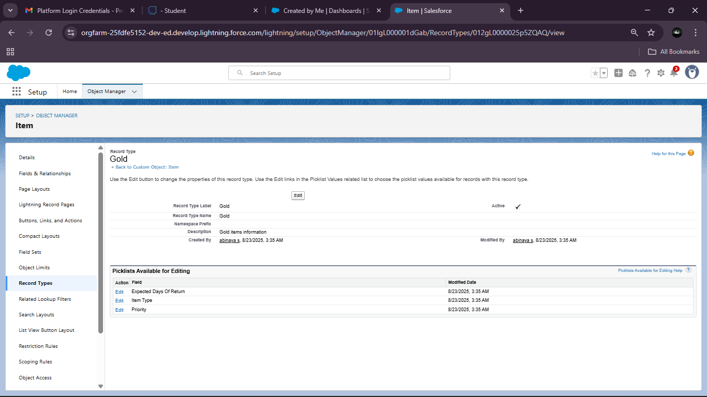

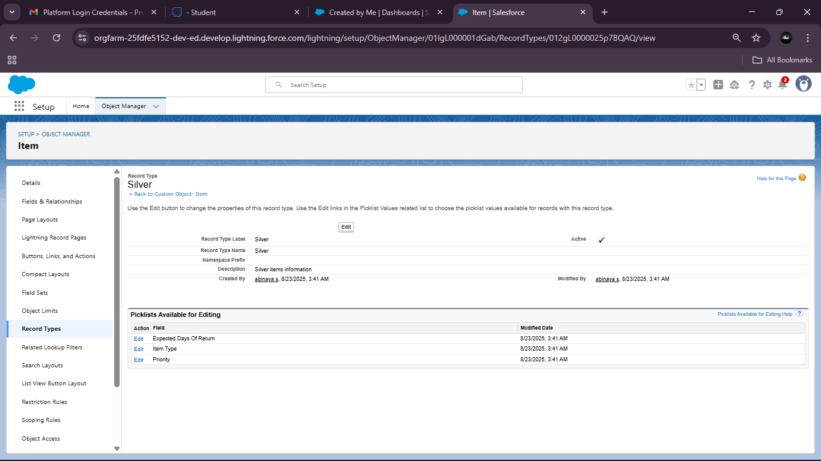

Permission sets:

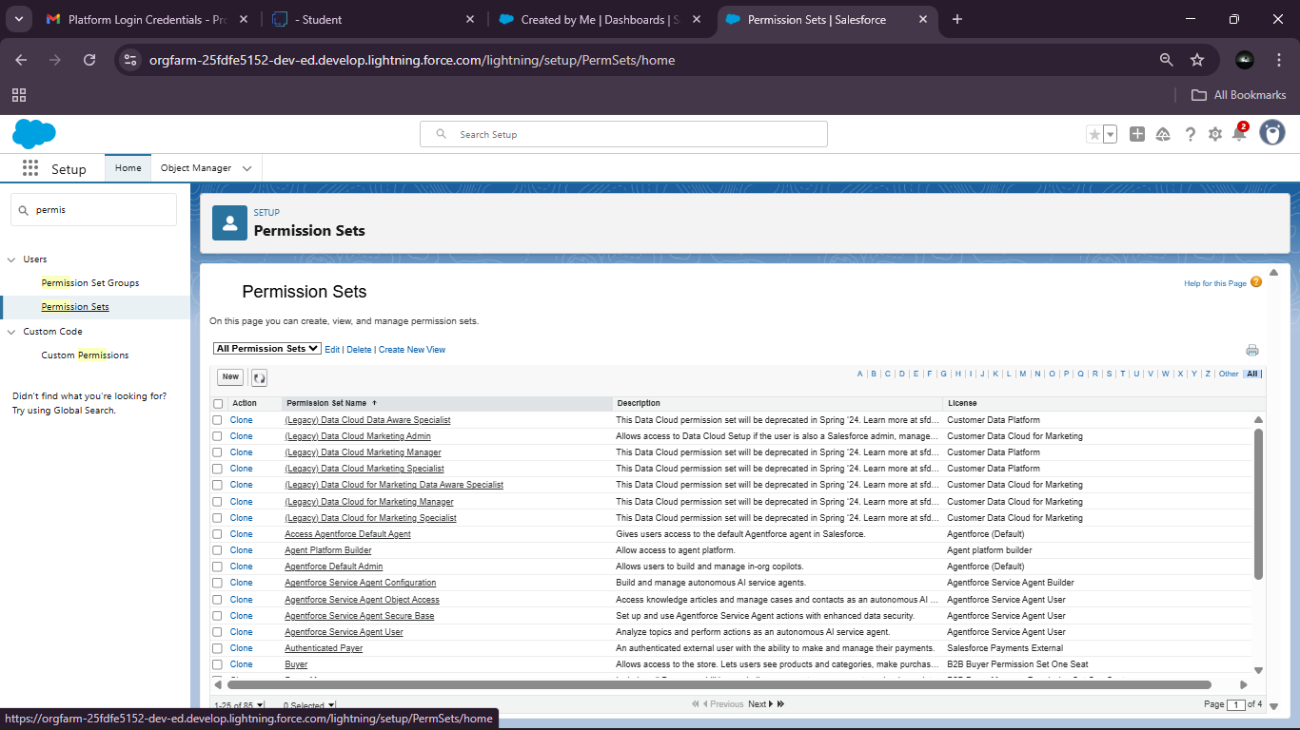

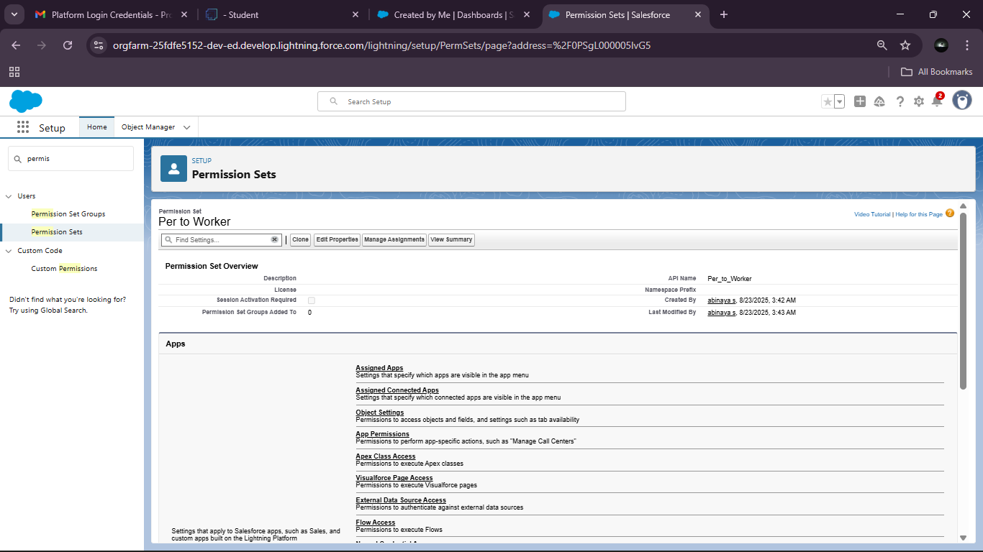

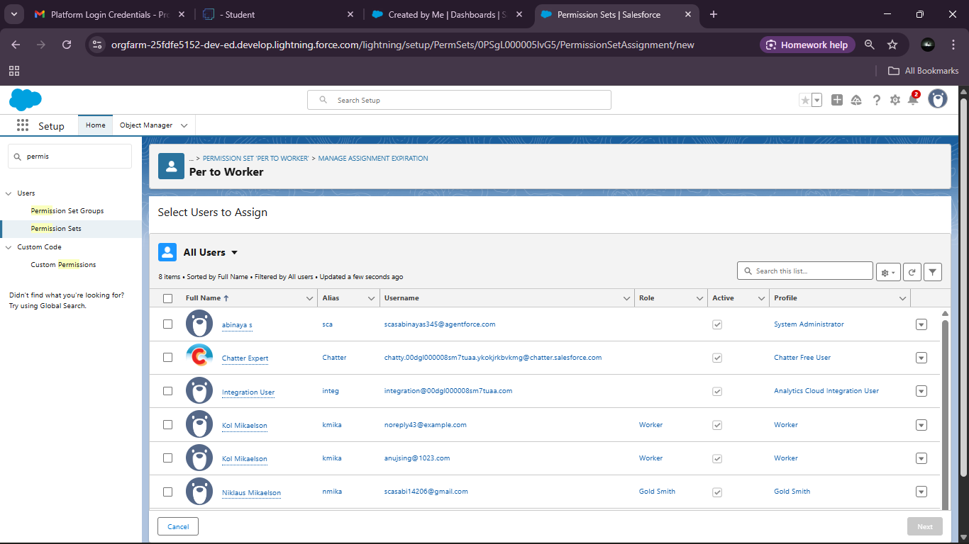

**FUNCTIONAL AND PERFORMANCE TESTING**

Performance Testing

**Trigger Handler class:**

# public class UpdatePaidAmountTriggerHandler {

# public static void handleBeforeInsert(List<Billing__c> newBillings) {

# for (Billing__c billing : newBillings) {

# billing.Paid_Amount__c = billing.Paying_Amount__c;

# }

# }

# 

# public static void handleBeforeUpdate(Map<Id, Billing__c> oldBillingsMap, List<Billing__c> updatedBillings) {

# for (Billing__c billing : updatedBillings) {

# Billing__c oldBilling = oldBillingsMap.get(billing.Id);

# Decimal oldPaidAmount = oldBilling.Paid_Amount__c;

# billing.Paid_Amount__c = oldPaidAmount + billing.Paying_Amount__c;

# }

# }

# }

**Create the trigger:**

# trigger UpdatePaidAmountTrigger on Billing__c (before insert, before update) {

# if (Trigger.isInsert) {

# UpdatePaidAmountTriggerHandler.handleBeforeInsert(Trigger.new);

# } else if (Trigger.isUpdate) {

# UpdatePaidAmountTriggerHandler.handleBeforeUpdate(Trigger.oldMap, Trigger.new);

# }

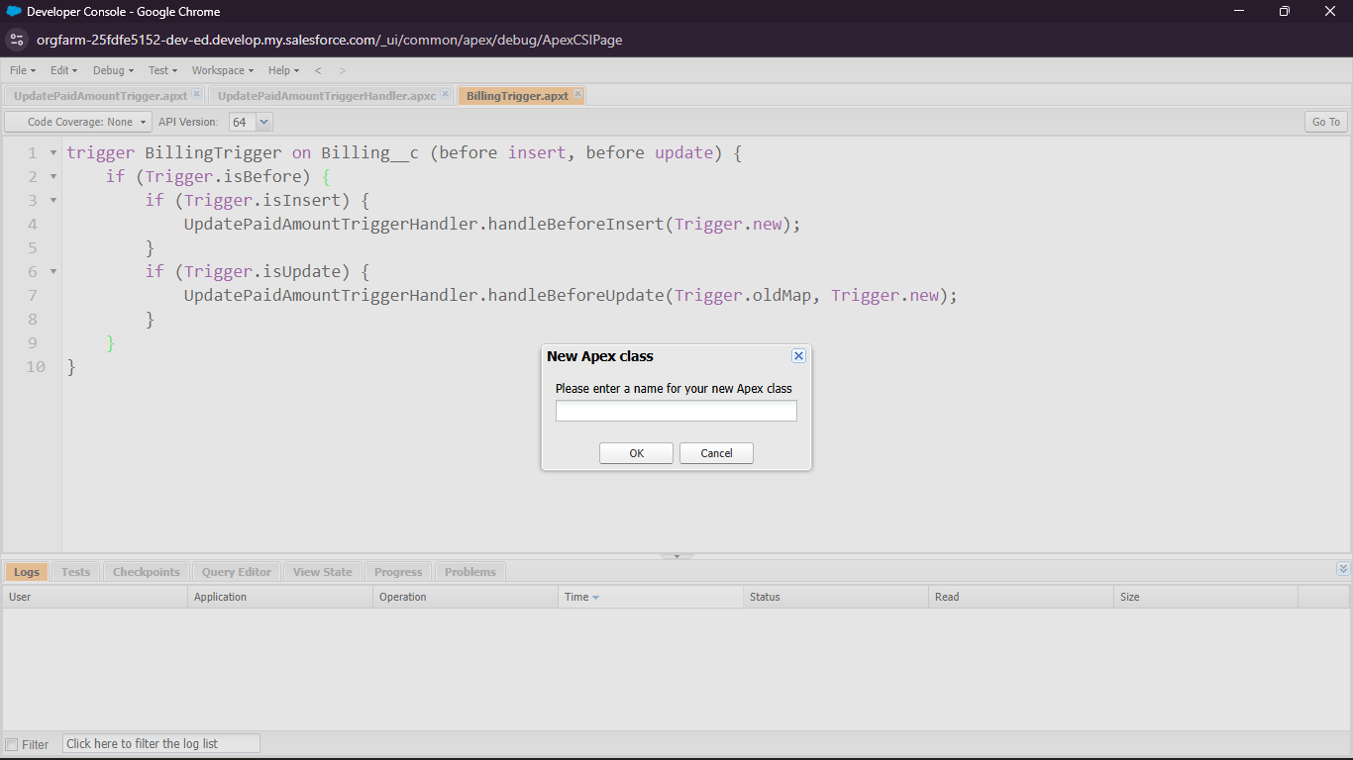

User Adoption:

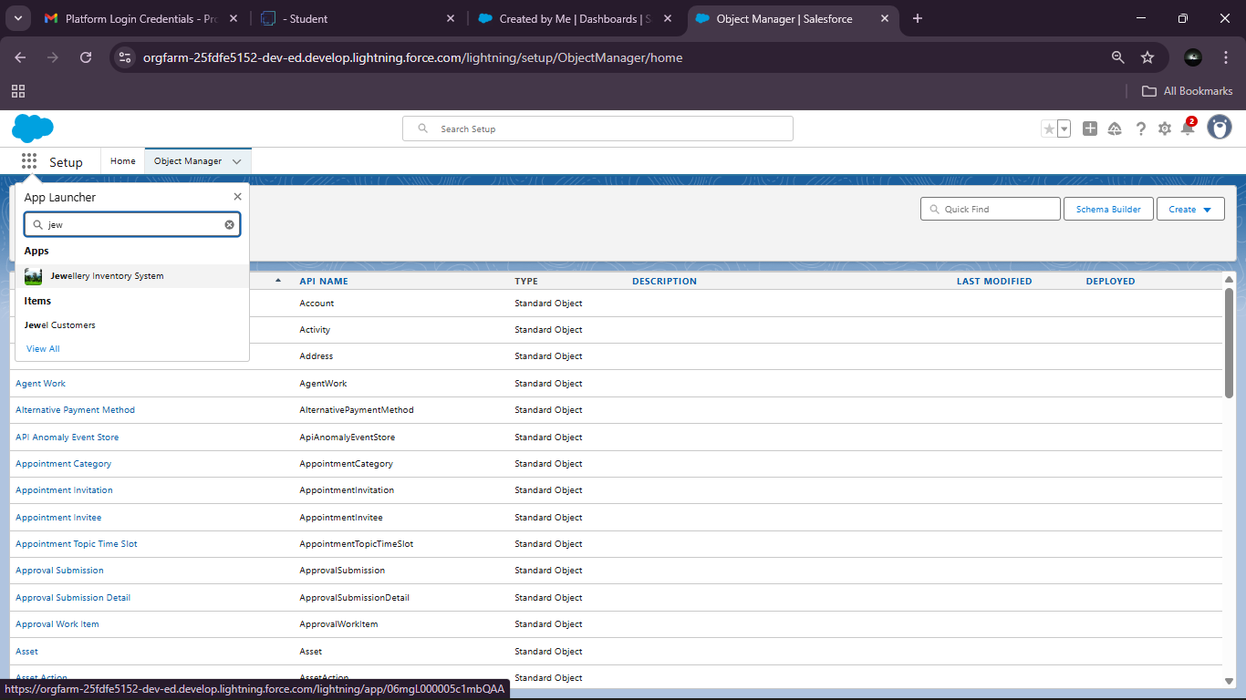

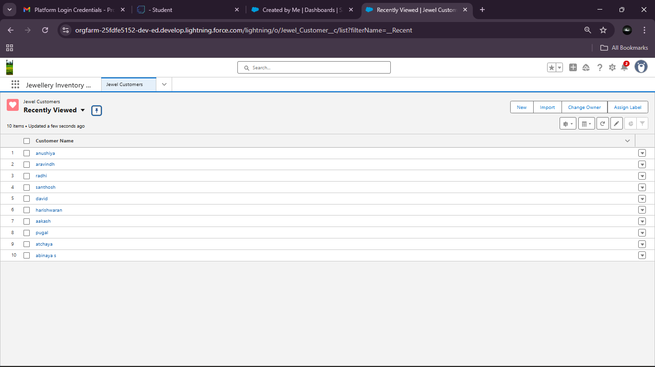

Reports:

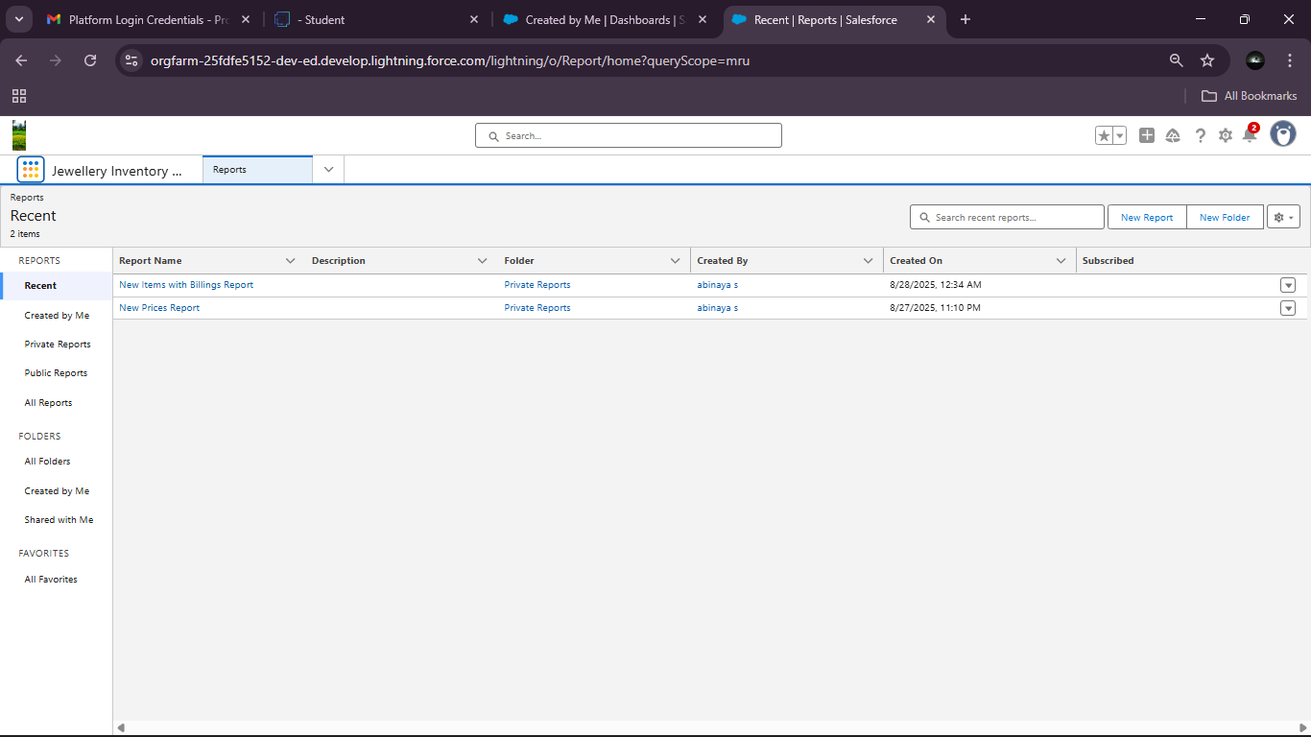

### RESULTS

### Dashboards:

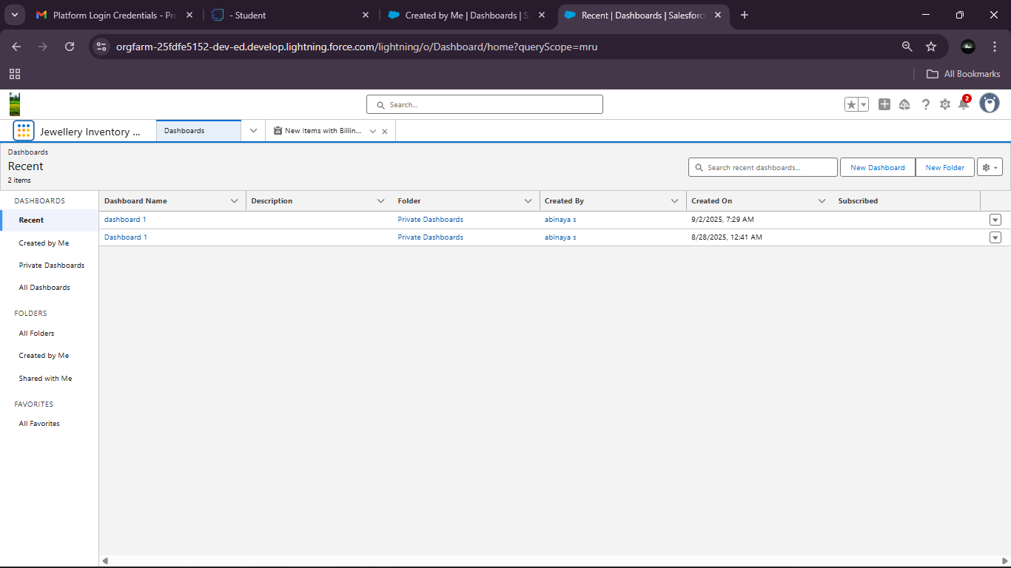

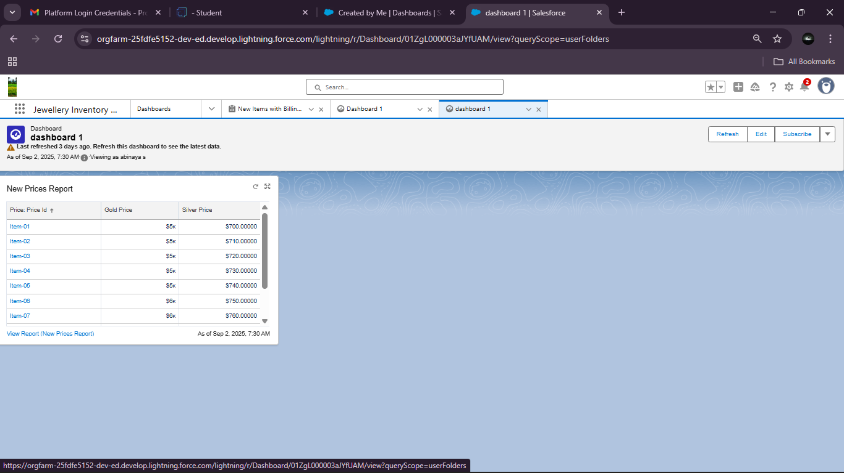

### Flows:

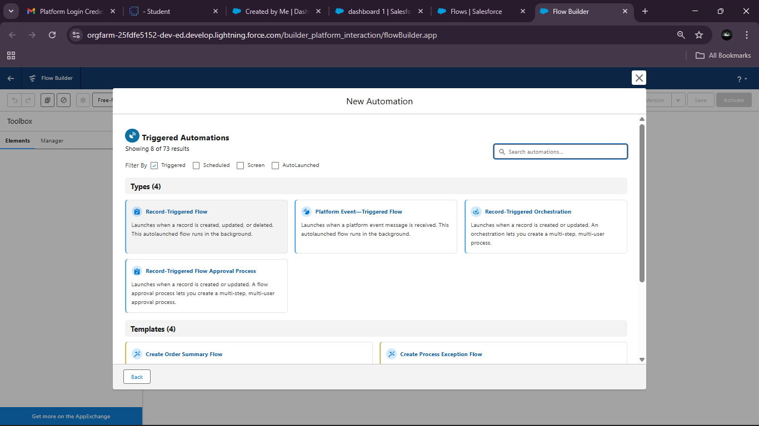

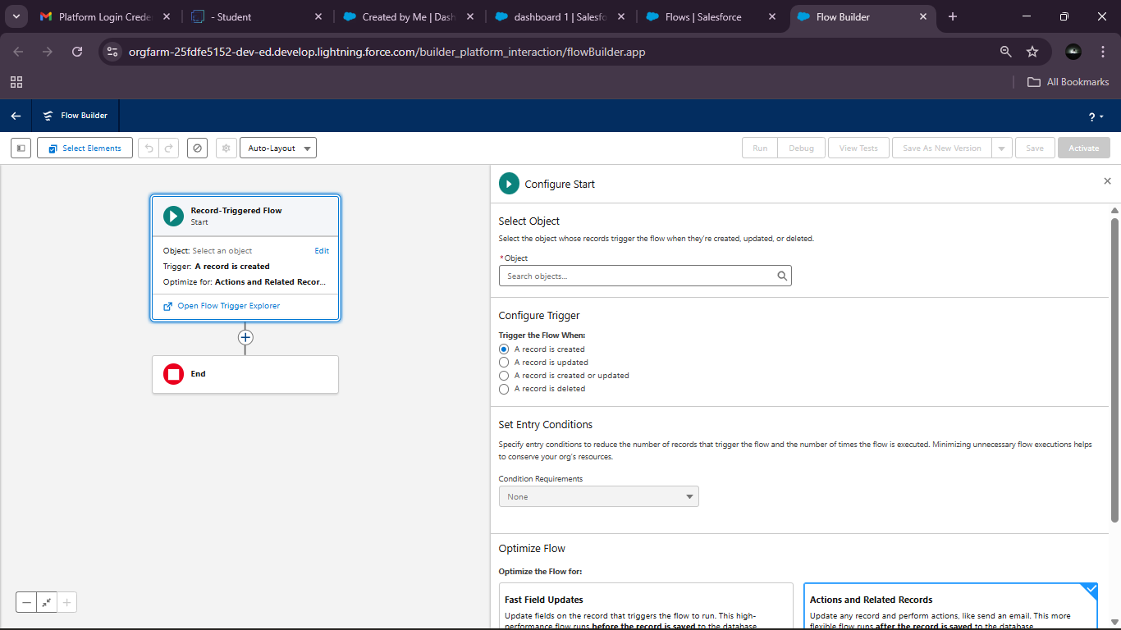

**CONCLUSION**

The CRM Application for Jewel Management successfully demonstrates the integration of Salesforce to streamline jewellery business operations, including inventory management, customer relationship handling, and sales tracking. By leveraging features such as custom objects, field dependencies, validation rules, workflows, email alerts, and dashboards, the system ensures accuracy, efficiency, and automation in managing jewellery processes. Overall, this project highlights how CRM solutions can enhance operational performance, improve customer satisfaction, and provide actionable insights for better decision-making in the jewellery industry.

• **Improved Accuracy:** Minimizes manual errors by automating record-keeping and sales tracking.

• **Operational Efficiency:** Streamlines the entire jewellery management process from inventory handling to customer engagement.

• **Customization:** Provides flexibility through custom objects, page layouts, and field dependencies tailored to business needs.

• **Automation:** Enhances productivity with workflows, triggers, flows, and email alerts that reduce repetitive tasks.

Overall, the project demonstrates how a robust CRM solution can transform traditional jewellery management into a modern, automated, and customer-centric system that promotes efficiency, compliance, and long-term business growth.